Equality in Geometric Constructions
# Source: AI Source: Provided by: [Data Path: Persons Table -> ID Column: 1, Name_En Column: Motasem Essam] -> From: [ChatGPT] on [7/25/2026]
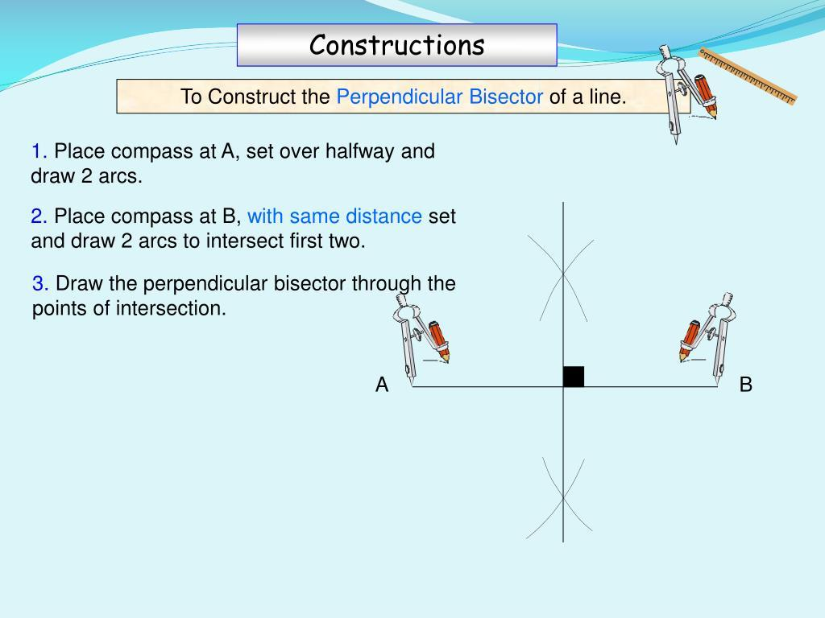
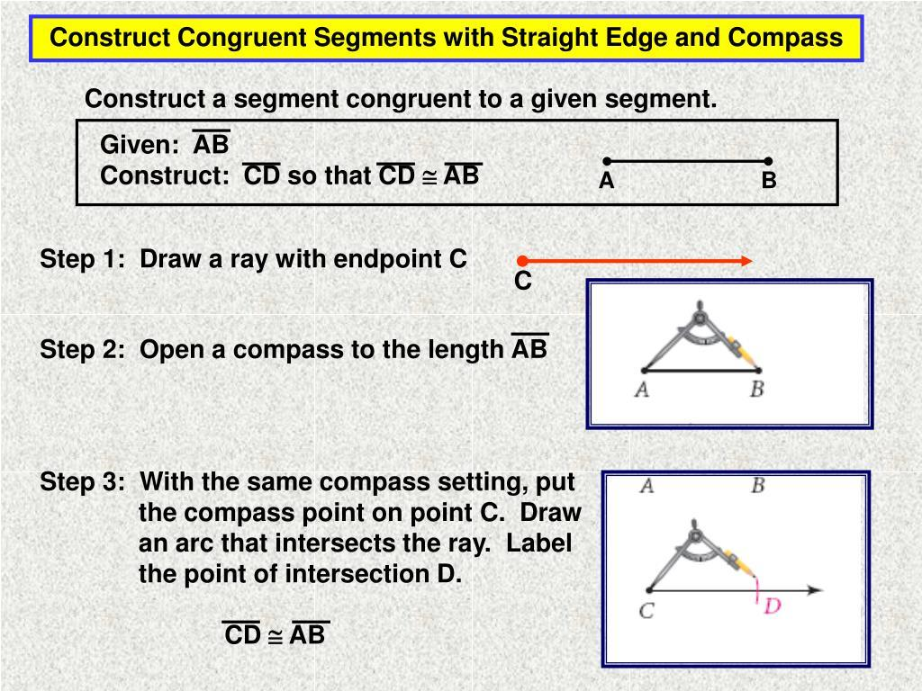
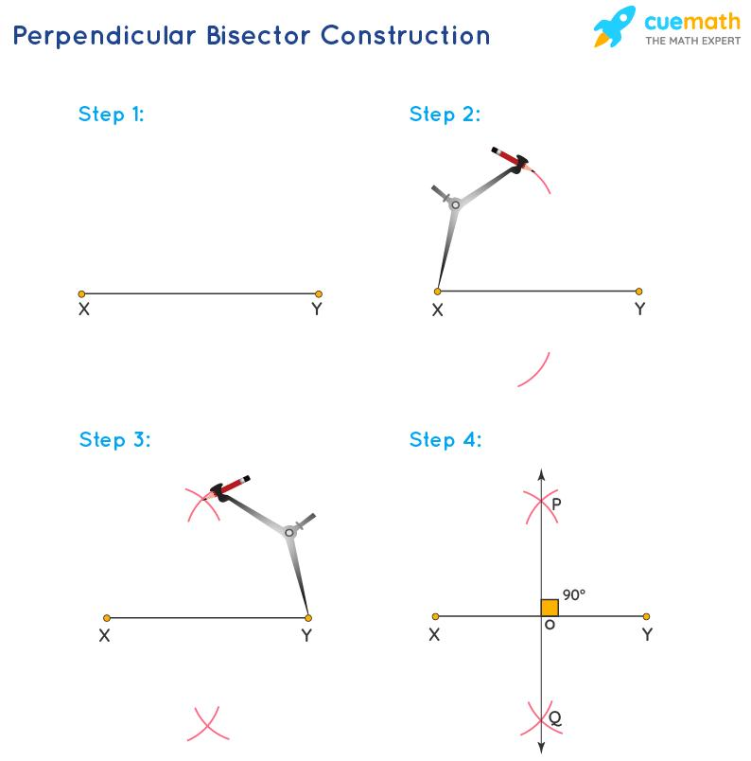
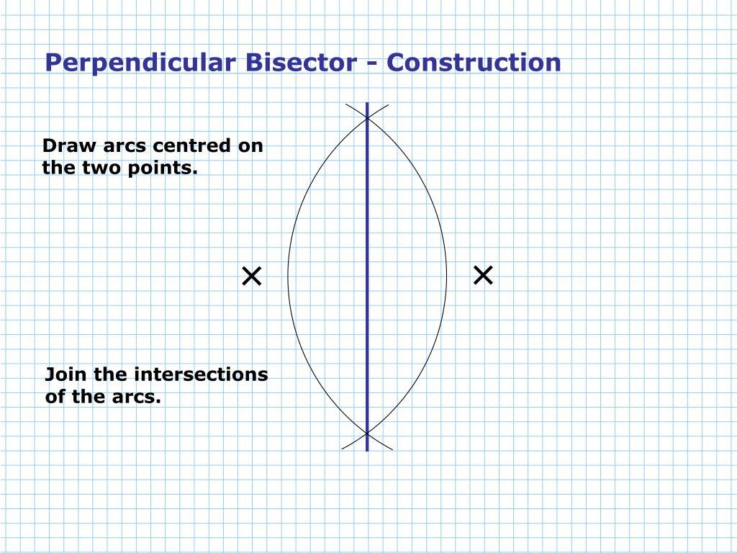
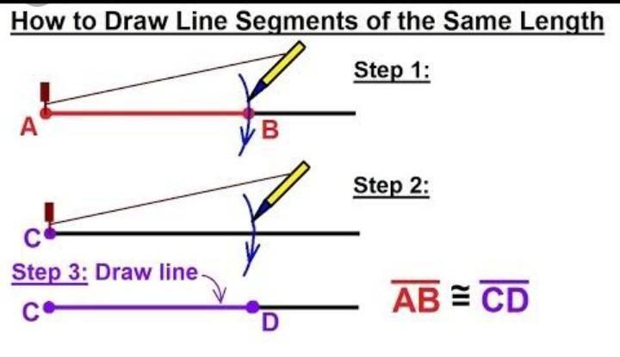

Definition
# Source: AI Source: Provided by: [Data Path: Persons Table -> ID Column: 1, Name_En Column: Motasem Essam] -> From: [ChatGPT] on [7/25/2026]
Equality in Geometric Constructions is a type of geometric equality in which an exact equality is created, transferred, or established through a geometric construction.
Geometric constructions use tools and procedures such as a compass, straightedge, perpendicular construction, angle construction, and transformations to produce precise geometric relationships.
$$\boxed{\text{Construction}→\text{Geometric Relationship}→\text{Equality}}$$
For example, when constructing the perpendicular bisector of $\overset{‾}{AB}$, the construction produces points that are equally distant from $A$and $B$:
$$\boxed{PA=PB}$$

Simple Definition
# Source: AI Source: Provided by: [Data Path: Persons Table -> ID Column: 1, Name_En Column: Motasem Essam] -> From: [ChatGPT] on [7/25/2026]
Equality in Geometric Constructions means exact equality that is produced or guaranteed by the steps of a geometric construction.
Examples:
$$\boxed{AB=CD}$$
when a segment is copied,
$$\boxed{AM=MB}$$
when a midpoint is constructed,
and
$$\boxed{m∠BAD=m∠DAC}$$
when an angle bisector is constructed.

Fundamental Concept
# Source: AI Source: Provided by: [Data Path: Persons Table -> ID Column: 1, Name_En Column: Motasem Essam] -> From: [ChatGPT] on [7/25/2026]
A geometric construction is designed to create a particular geometric relationship.
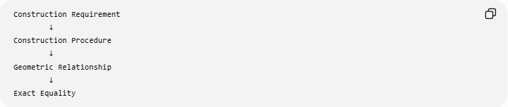
Construction Requirement
↓
Construction Procedure
↓
Geometric Relationship
↓
Exact Equality
For example:
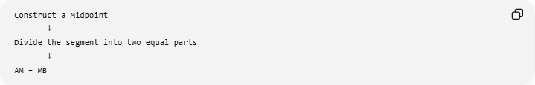
Construct a Midpoint
↓
Divide the segment into two equal parts
↓
AM = MB
Or:
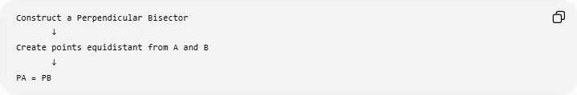
Construct a Perpendicular Bisector
↓
Create points equidistant from A and B
↓
PA = PB

Main Types
# Source: AI Source: Provided by: [Data Path: Persons Table -> ID Column: 1, Name_En Column: Motasem Essam] -> From: [ChatGPT] on [7/25/2026]
A practical classification is:
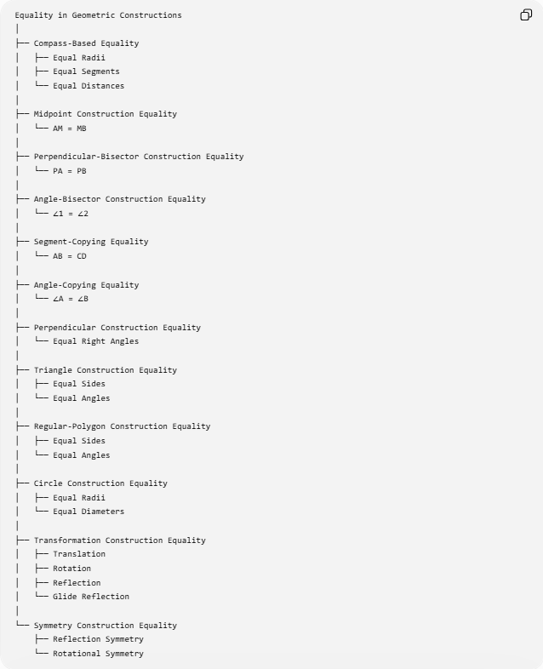
Equality in Geometric Constructions
│
├── Compass-Based Equality
│ ├── Equal Radii
│ ├── Equal Segments
│ └── Equal Distances
│
├── Midpoint Construction Equality
│ └── AM = MB
│
├── Perpendicular-Bisector Construction Equality
│ └── PA = PB
│
├── Angle-Bisector Construction Equality
│ └── ∠1 = ∠2
│
├── Segment-Copying Equality
│ └── AB = CD
│
├── Angle-Copying Equality
│ └── ∠A = ∠B
│
├── Perpendicular Construction Equality
│ └── Equal Right Angles
│
├── Triangle Construction Equality
│ ├── Equal Sides
│ └── Equal Angles
│
├── Regular-Polygon Construction Equality
│ ├── Equal Sides
│ └── Equal Angles
│
├── Circle Construction Equality
│ ├── Equal Radii
│ └── Equal Diameters
│
├── Transformation Construction Equality
│ ├── Translation
│ ├── Rotation
│ ├── Reflection
│ └── Glide Reflection
│
└── Symmetry Construction Equality
├── Reflection Symmetry
└── Rotational Symmetry
Note: This is a practical classification based on how constructions establish equality. It is not a universally standardized taxonomy.

Equality from Compass Construction
# Source: AI Source: Provided by: [Data Path: Persons Table -> ID Column: 1, Name_En Column: Motasem Essam] -> From: [ChatGPT] on [7/25/2026]
The compass is one of the most important tools for constructing exact equality.
When a compass is opened to a particular distance, that opening can be transferred without changing its length.
If the compass is set to:
$$AB,$$
and that opening is used to construct $CD$, then:
$$\boxed{CD=AB}$$
Example
If:
$$AB=6\text{ cm},$$
the compass opening is set to $6$cm and transferred to another location.
The constructed segment satisfies:
$$\boxed{CD=6\text{ cm}}$$
so:
$$\boxed{AB=CD}.$$
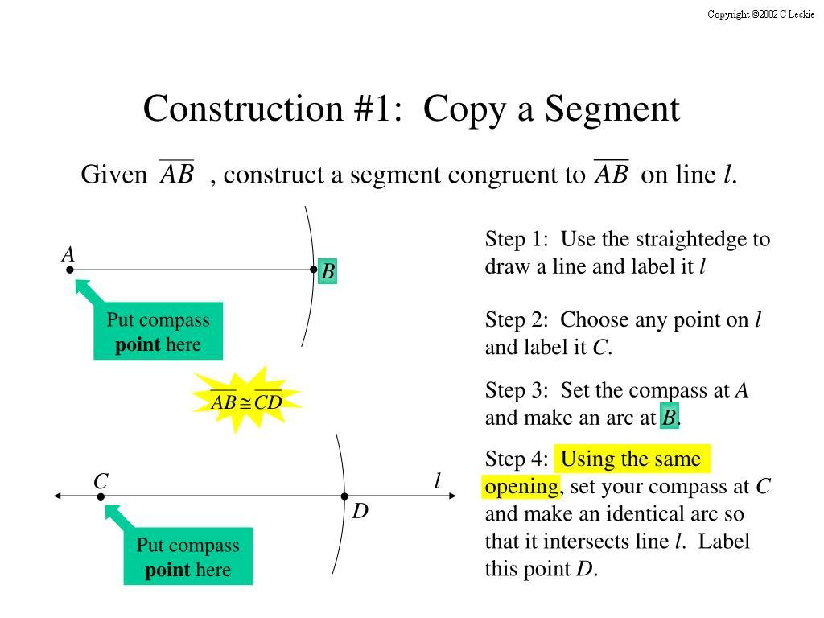
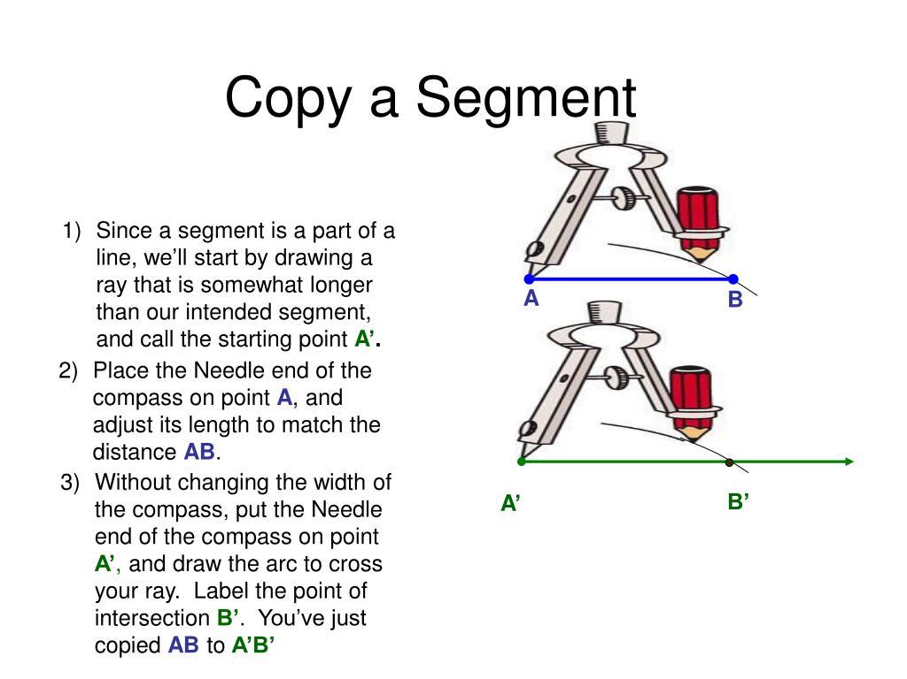
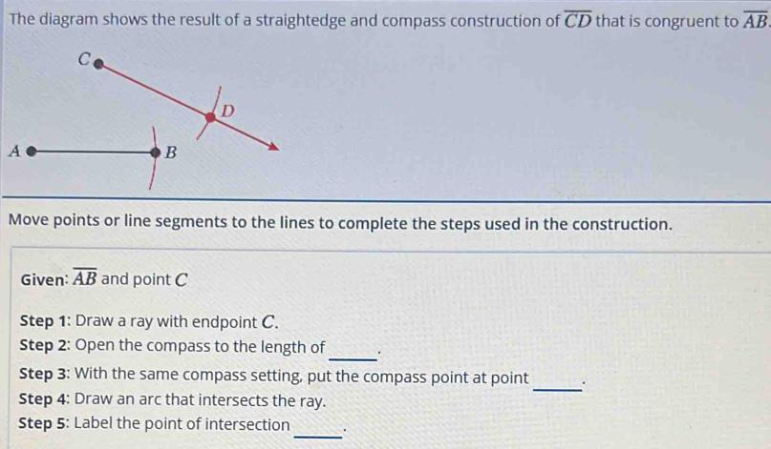

Equality from Equal Compass Radii
# Source: AI Source: Provided by: [Data Path: Persons Table -> ID Column: 1, Name_En Column: Motasem Essam] -> From: [ChatGPT] on [7/25/2026]
When several arcs are drawn using the same compass opening, their radii are equal.
If arcs centered at $A$, $B$, and $C$are drawn with the same compass opening $r$:
$$\boxed{r_{A}=r_{B}=r_{C}=r}$$
For example:
$$PA=PB=6\text{ cm}.$$
This principle is fundamental to many constructions.
Used for
- perpendicular bisectors,
- angle bisectors,
- equilateral triangles,
- copying segments,
- copying angles,
- regular polygons.

Equality from Midpoint Construction
# Source: AI Source: Provided by: [Data Path: Persons Table -> ID Column: 1, Name_En Column: Motasem Essam] -> From: [ChatGPT] on [7/25/2026]
A midpoint construction divides a segment into two equal parts.
Given:
$$\overset{‾}{AB},$$
construct its midpoint $M$.
The result is:
$$\boxed{AM=MB}$$
Construction
- Draw an arc centered at $A$.
- Draw an arc centered at $B$using the same radius.
- Let the arcs intersect at $P$and $Q$.
- Draw $PQ$.
- $PQ$intersects $AB$at $M$.
Then:
$$\boxed{AM=MB}.$$
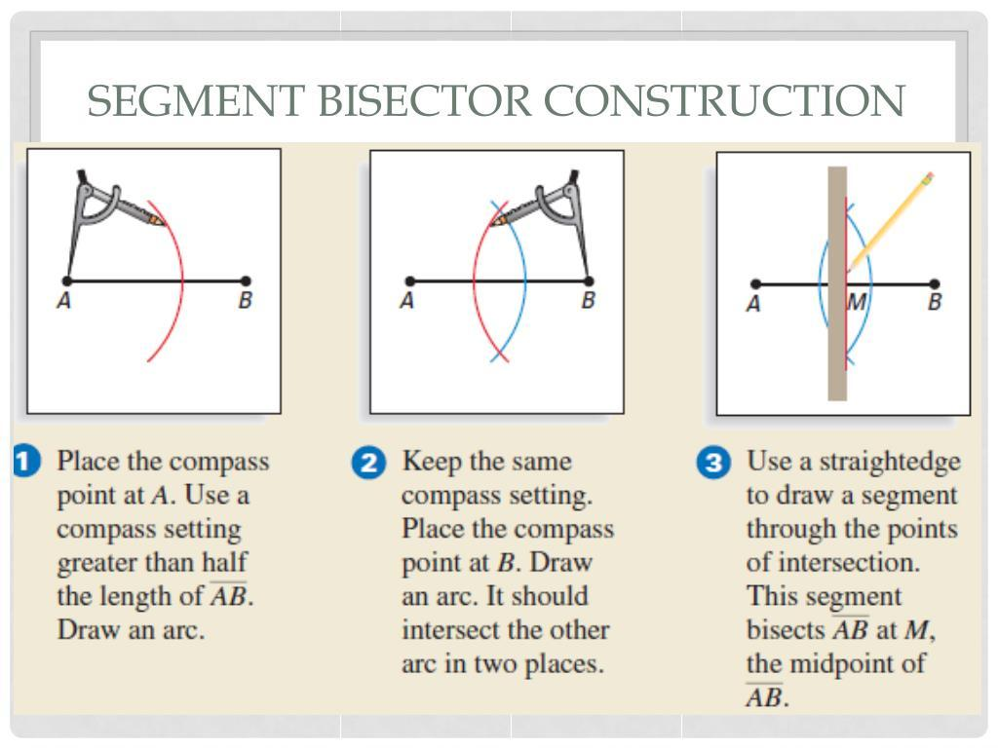
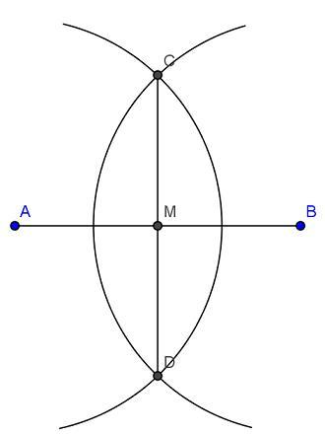
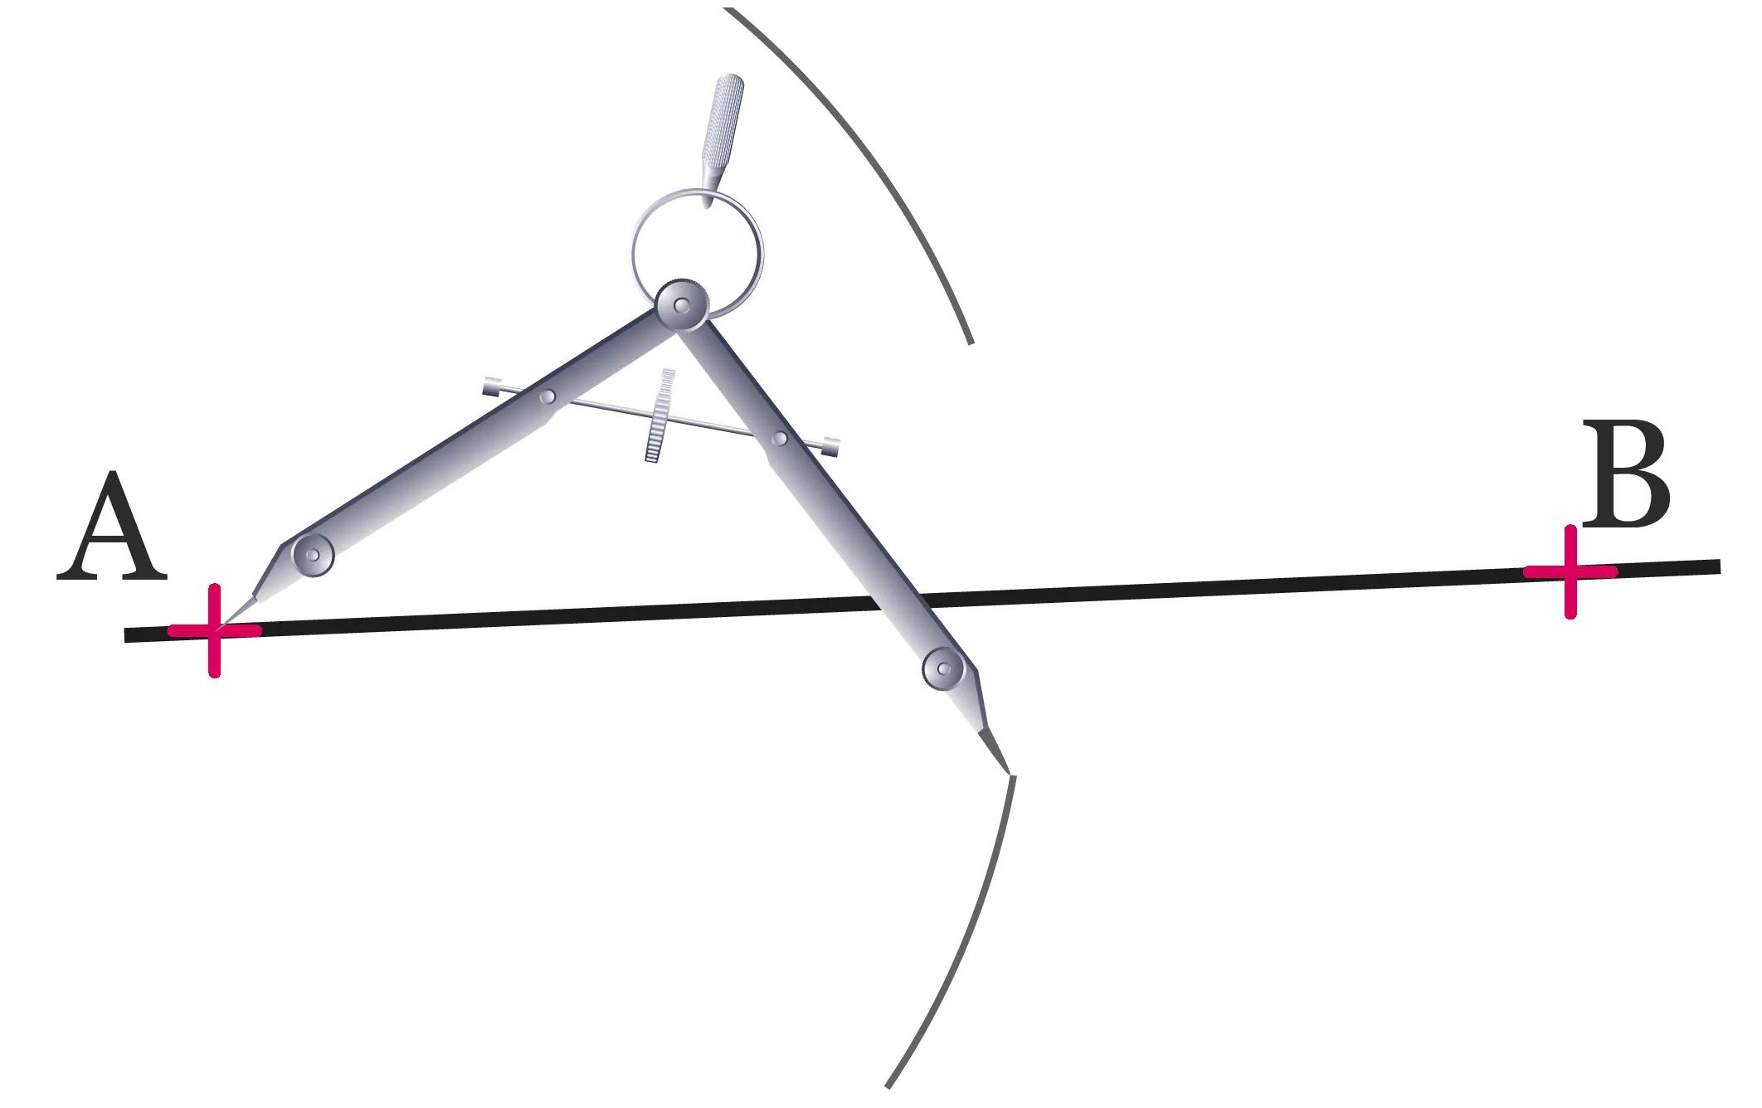
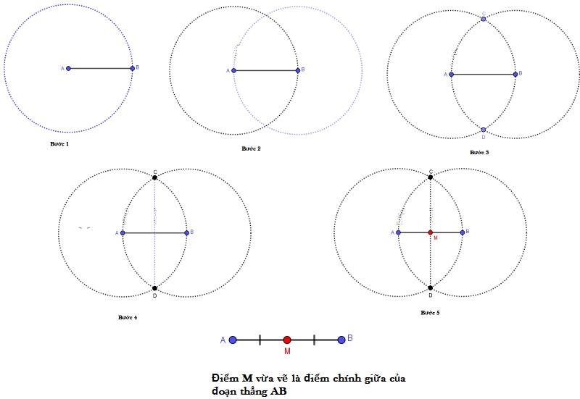

Equality from Perpendicular-Bisector Construction
# Source: AI Source: Provided by: [Data Path: Persons Table -> ID Column: 1, Name_En Column: Motasem Essam] -> From: [ChatGPT] on [7/25/2026]
The perpendicular bisector construction produces a line whose points are equidistant from the endpoints of the original segment.
For segment $AB$, construct its perpendicular bisector.
For every point $P$on that bisector:
$$\boxed{PA=PB}.$$
Construction principle
Two equal-radius arcs are drawn from $A$and $B$:
$$PA=PB$$
and:
$$QA=QB.$$
Connecting $P$and $Q$creates the perpendicular bisector.
Thus:
$$\boxed{P\text{ on perpendicular bisector}⇒PA=PB}$$
This also illustrates the relationship between construction and loci.
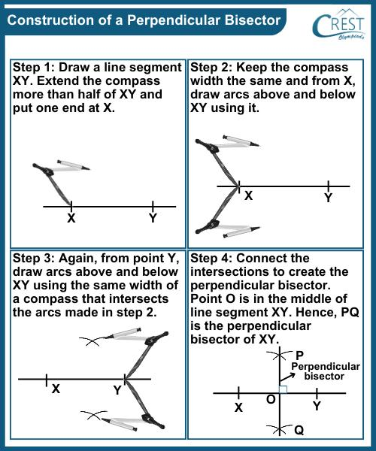
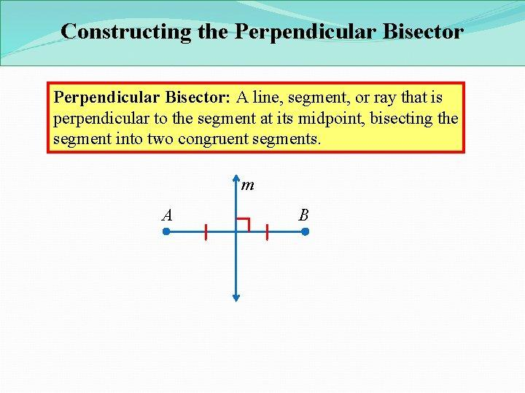
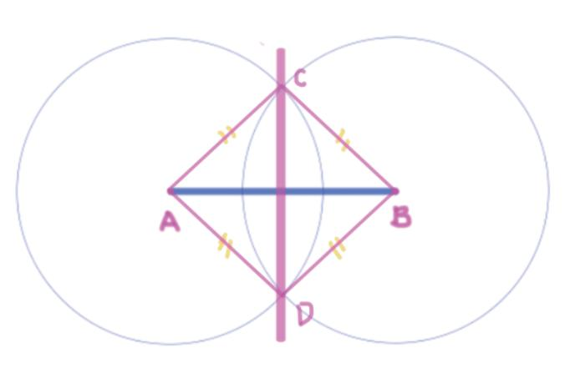

Equality from Angle-Bisector Construction
# Source: AI Source: Provided by: [Data Path: Persons Table -> ID Column: 1, Name_En Column: Motasem Essam] -> From: [ChatGPT] on [7/25/2026]
An angle bisector divides an angle into two equal angles.
Given:
$$∠BAC,$$
construct $AD$as its angle bisector.
Then:
$$\boxed{m∠BAD=m∠DAC}$$
Construction
- Draw an arc centered at $A$.
- Mark its intersections with the two sides of the angle.
- Draw equal-radius arcs from those two points.
- Connect their intersection to $A$.
The resulting ray $AD$bisects the original angle.
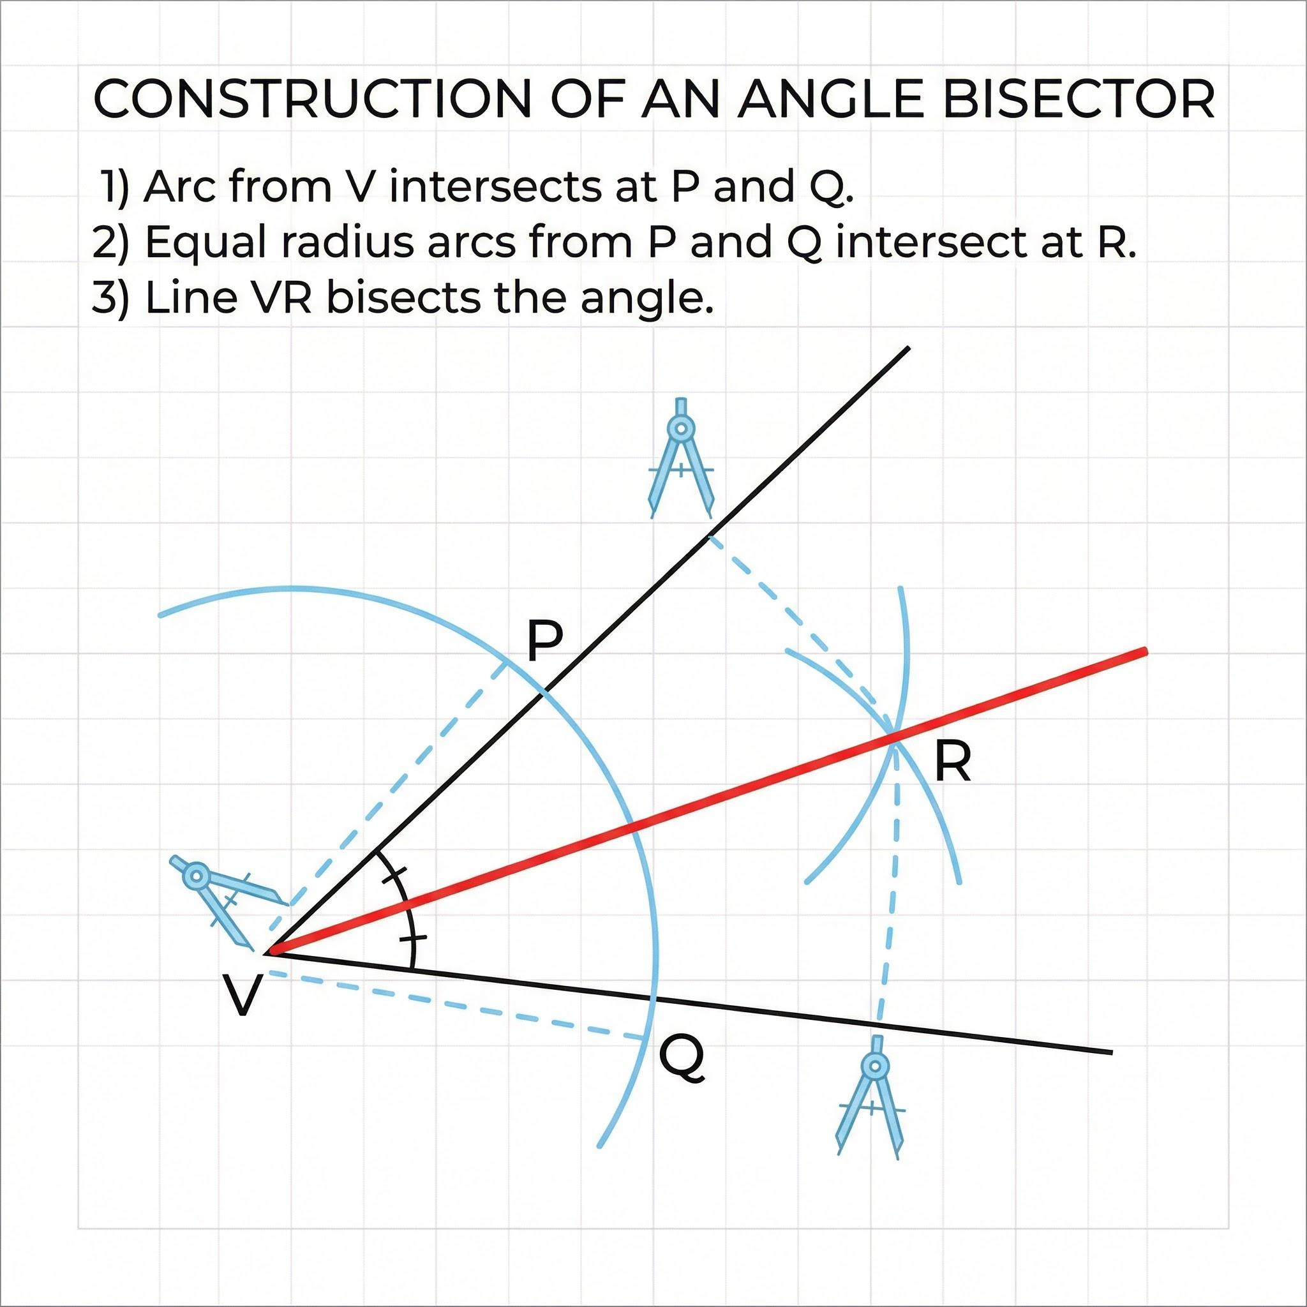
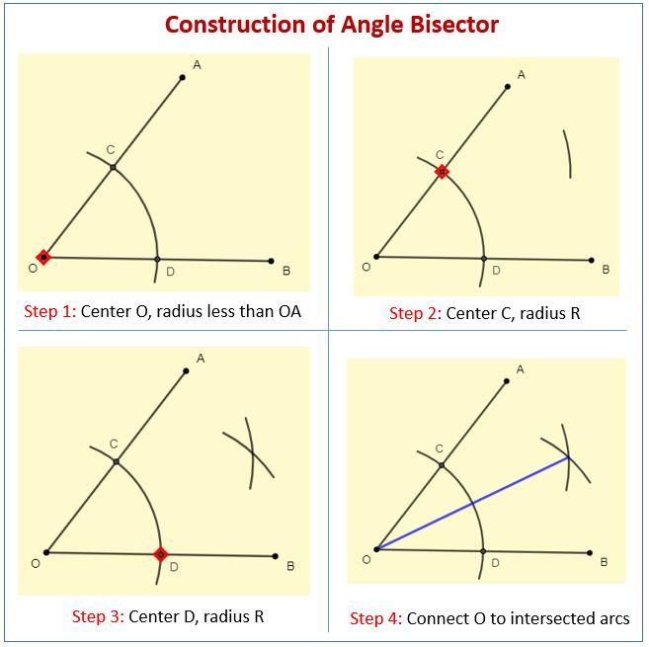
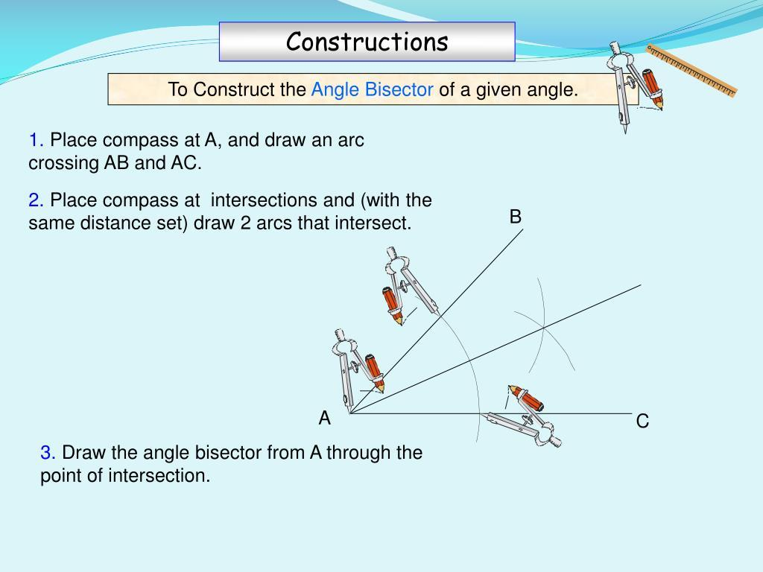
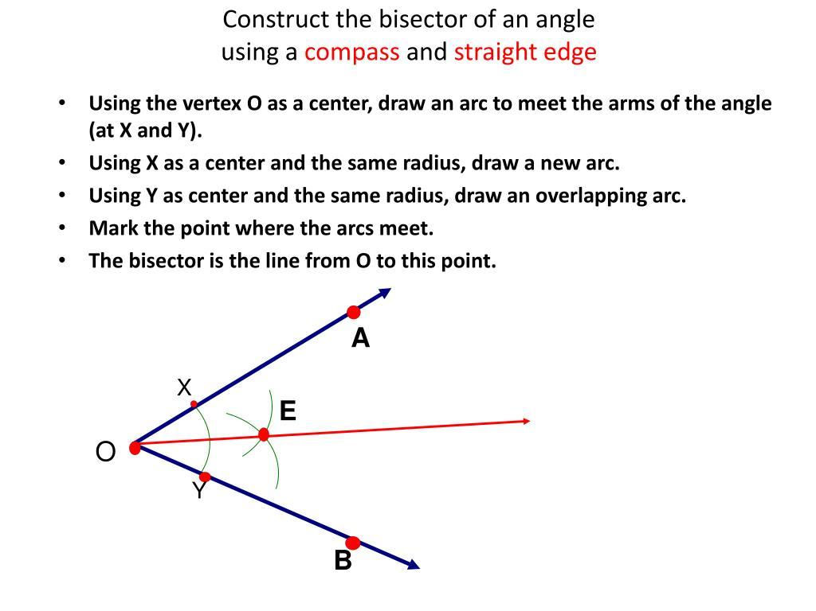

Equality from Copying a Segment
# Source: AI Source: Provided by: [Data Path: Persons Table -> ID Column: 1, Name_En Column: Motasem Essam] -> From: [ChatGPT] on [7/25/2026]
A segment can be copied exactly.
Given:
$$\overset{‾}{AB},$$
construct a new segment $\overset{‾}{CD}$with the same length.
Then:
$$\boxed{CD=AB}.$$
Construction principle
The compass opening is set to $AB$:
$$\text{Compass opening}=AB.$$
The same opening is transferred to $C$, producing $D$.
Therefore:
$$\boxed{CD=AB}.$$

Equality from Copying an Angle
# Source: AI Source: Provided by: [Data Path: Persons Table -> ID Column: 1, Name_En Column: Motasem Essam] -> From: [ChatGPT] on [7/25/2026]
An angle can also be copied exactly.
Suppose the original angle is:
$$∠ABC.$$
It is copied to a new vertex to create:
$$∠EDF.$$
The construction guarantees:
$$\boxed{m∠ABC=m∠EDF}$$
This is an example of angle equality produced through construction.
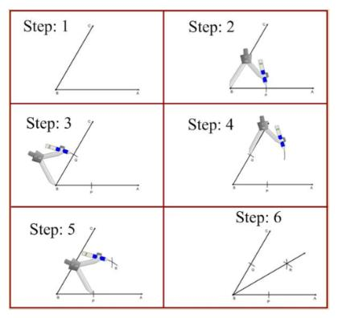
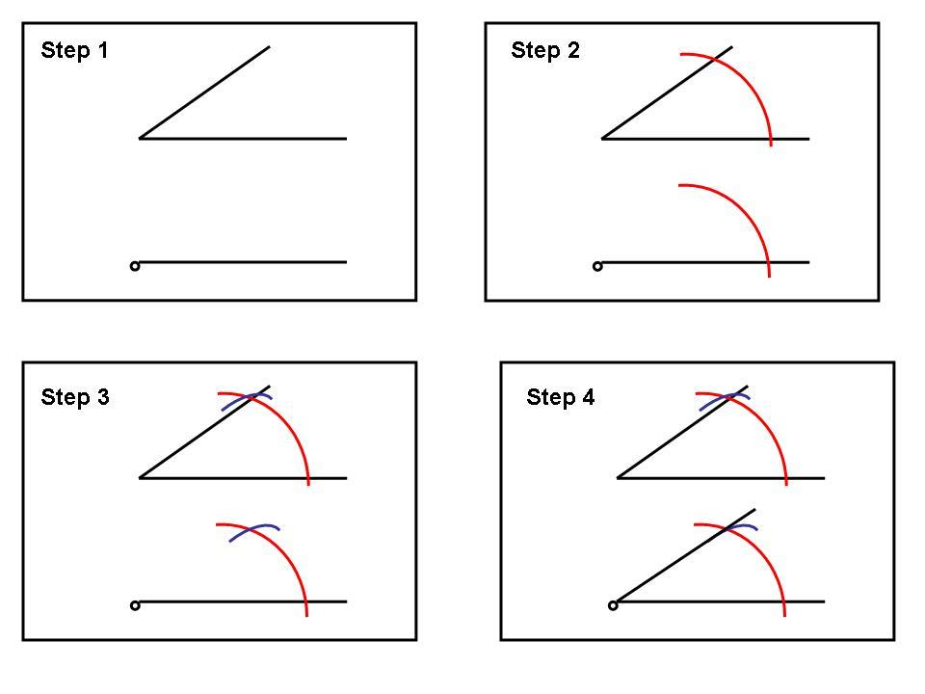
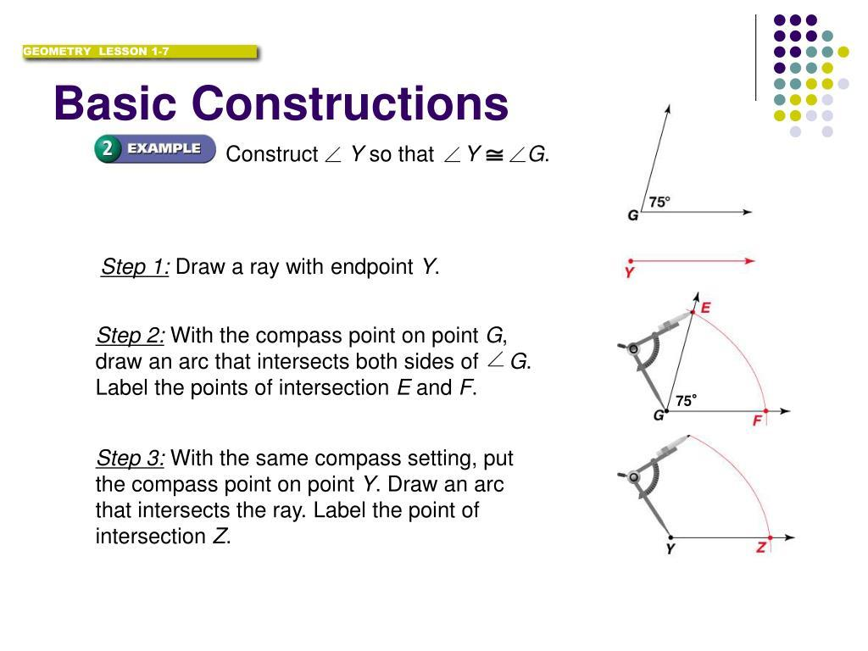
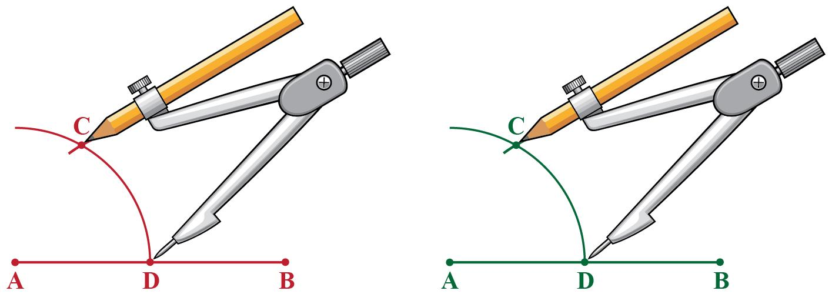

Equality from Perpendicular Construction
# Source: AI Source: Provided by: [Data Path: Persons Table -> ID Column: 1, Name_En Column: Motasem Essam] -> From: [ChatGPT] on [7/25/2026]
A perpendicular construction creates right angles.
If:
$$l⊥m,$$
then all four angles formed at their intersection are right angles:
$$\boxed{m∠1=m∠2=m∠3=m∠4={90}^{∘}}$$
Therefore:
$$\boxed{m∠1=m∠2}$$
and similarly for the other right angles.
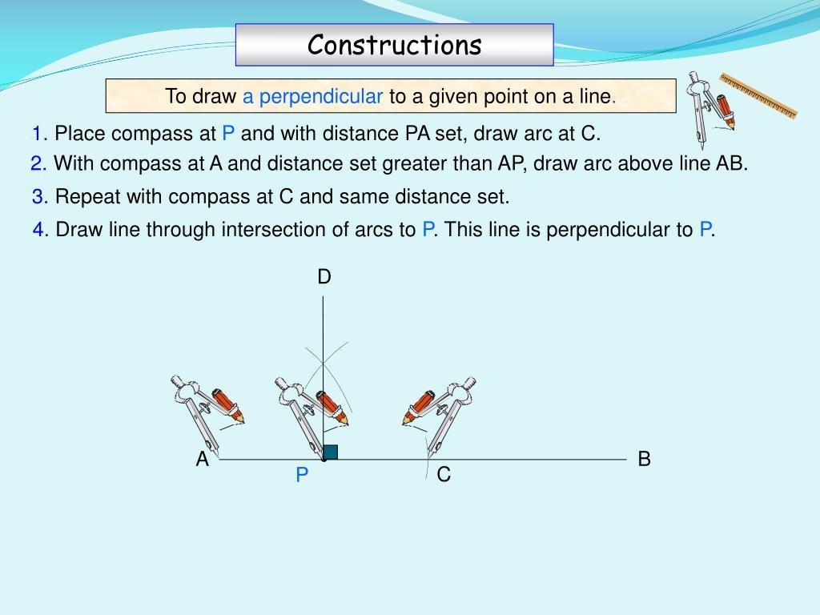
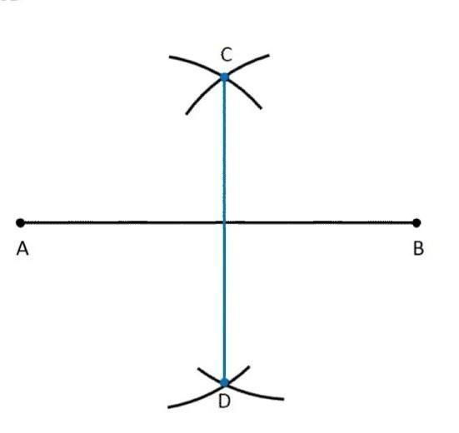
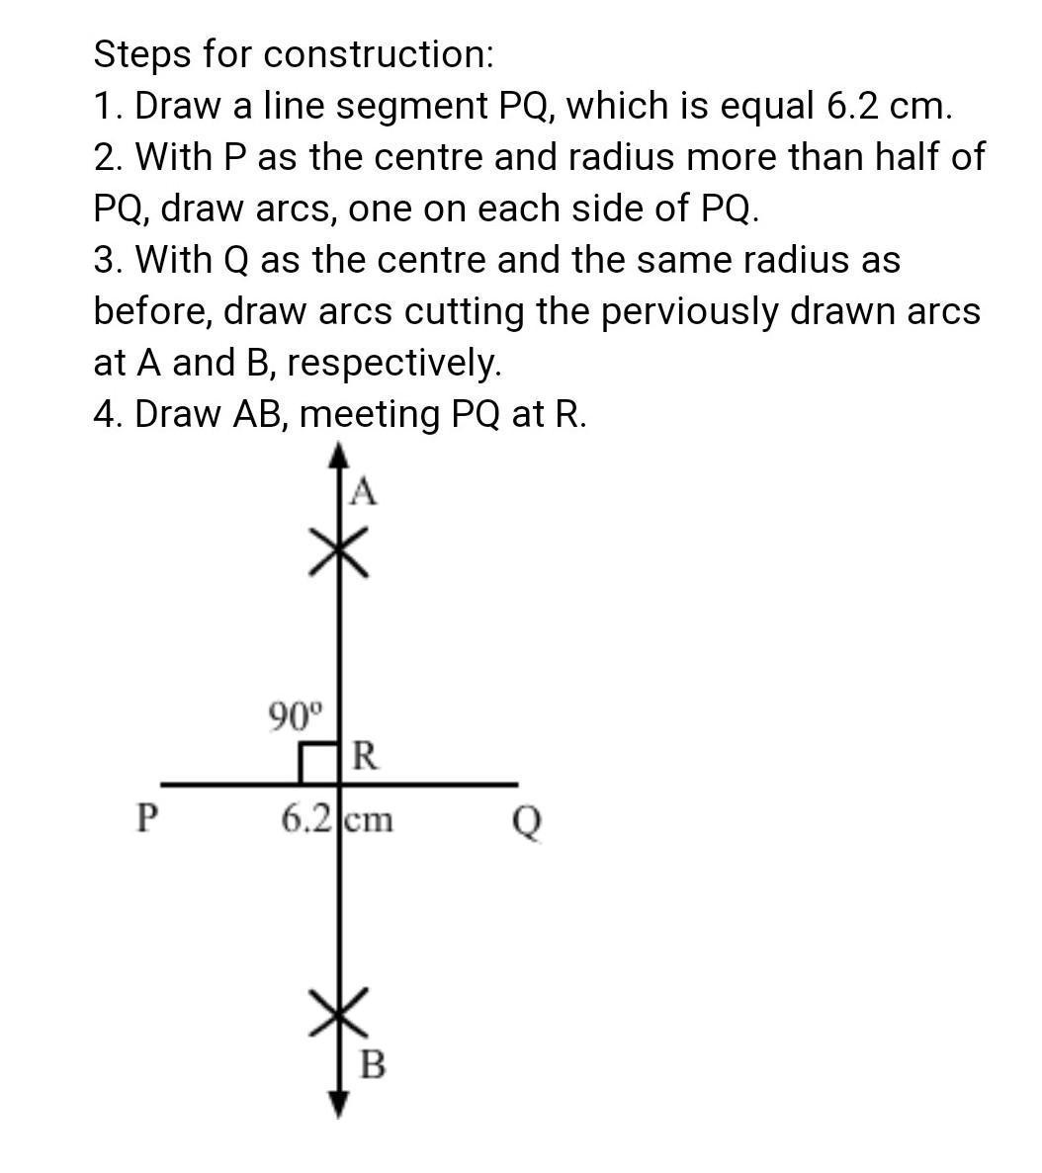
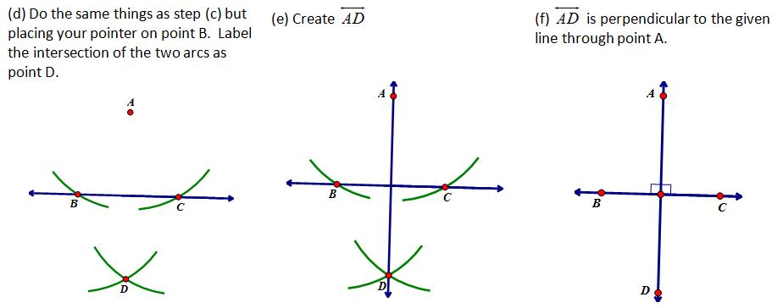
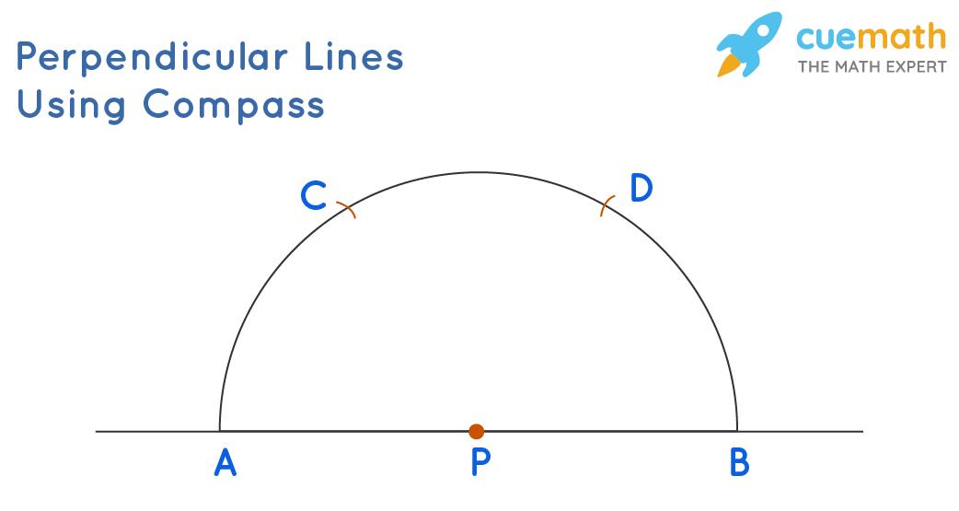

Equality from Parallel-Line Construction
# Source: AI Source: Provided by: [Data Path: Persons Table -> ID Column: 1, Name_En Column: Motasem Essam] -> From: [ChatGPT] on [7/25/2026]
A parallel line can be constructed through a given point.
Once the construction establishes:
$$l_{1}∥l_{2},$$
a transversal creates equal corresponding and alternate interior angles.
For example:
$$\boxed{m∠1=m∠2}$$
for corresponding angles.
The logical sequence is:
$$\boxed{\text{Construction}→\text{Parallel Lines}→\text{Parallel-Line Theorem}→\text{Angle Equality}}$$
Thus the equality may be indirectly produced by the construction through a theorem.

Equality from Equilateral-Triangle Construction
# Source: AI Source: Provided by: [Data Path: Persons Table -> ID Column: 1, Name_En Column: Motasem Essam] -> From: [ChatGPT] on [7/25/2026]
An equilateral triangle can be constructed from a given segment $AB$.
Construction
- Draw a circle centered at $A$with radius $AB$.
- Draw a circle centered at $B$with radius $AB$.
- Let the circles intersect at $C$.
- Connect $A$, $B$, and $C$.
Then:
$$AC=AB$$
and:
$$BC=AB.$$
Therefore:
$$\boxed{AB=BC=CA}.$$
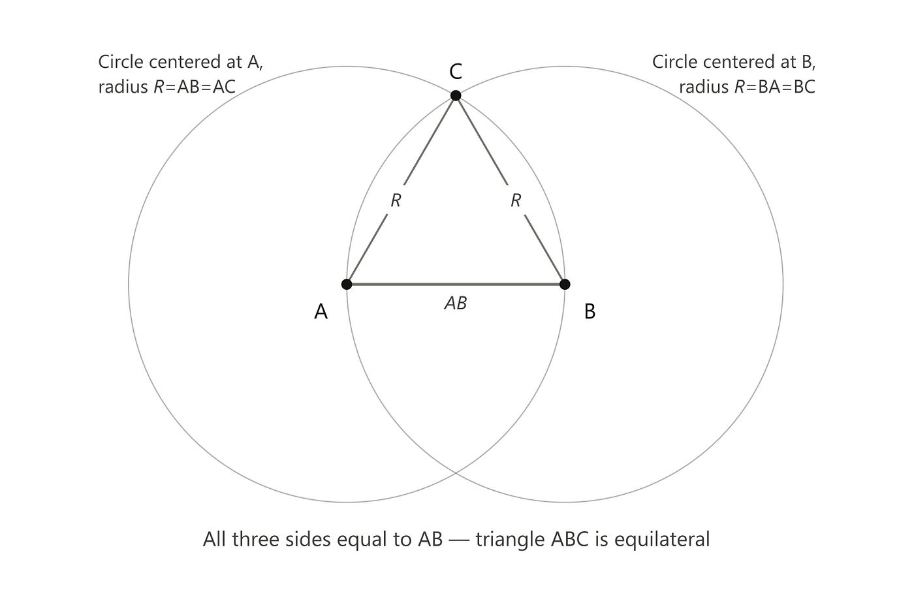
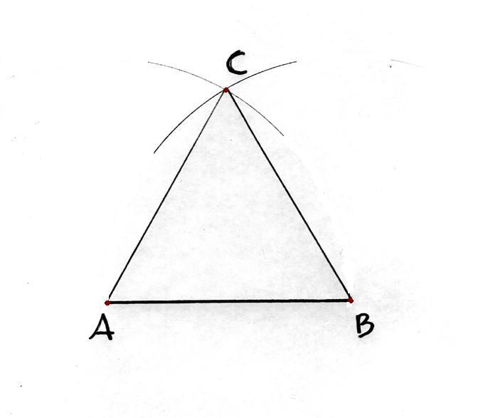
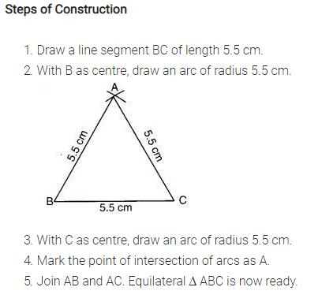
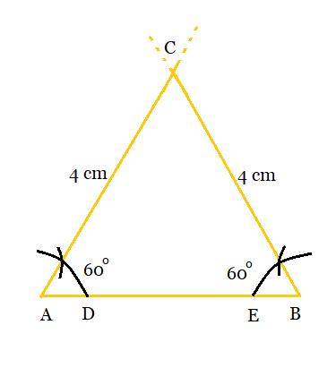
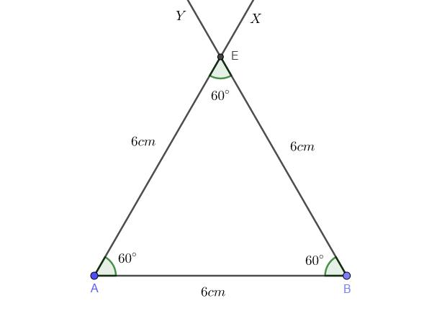

Equality from Triangle Construction
# Source: AI Source: Provided by: [Data Path: Persons Table -> ID Column: 1, Name_En Column: Motasem Essam] -> From: [ChatGPT] on [7/25/2026]
Geometric construction can create triangles with specified equal properties.
Equilateral triangle
$$\boxed{AB=BC=CA}$$
Isosceles triangle construction
If two equal sides are deliberately constructed:
$$\boxed{AB=AC}.$$
Congruent triangle construction
If the corresponding side lengths are copied:
$$AB=DE, \\ BC=EF, \\ AC=DF,$$
then:
$$\boxed{△ABC≅△DEF}.$$
The construction therefore creates the conditions for congruence and corresponding equality.

Equality from Circle Construction
# Source: AI Source: Provided by: [Data Path: Persons Table -> ID Column: 1, Name_En Column: Motasem Essam] -> From: [ChatGPT] on [7/25/2026]
When a circle is constructed with center $O$and radius $r$, every point on the circle is exactly $r$units from $O$.
Thus:
$$\boxed{OA=OB=OC=OD=r}$$
for points $A,B,C,D$on the circle.
Example
If the compass opening is:
$$r=5\text{ cm},$$
then:
$$OA=OB=OC=5\text{ cm}.$$
Therefore all constructed radii are equal.
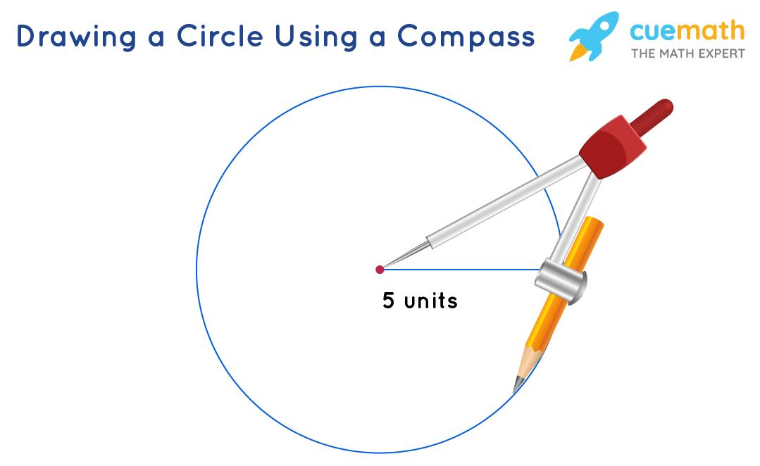
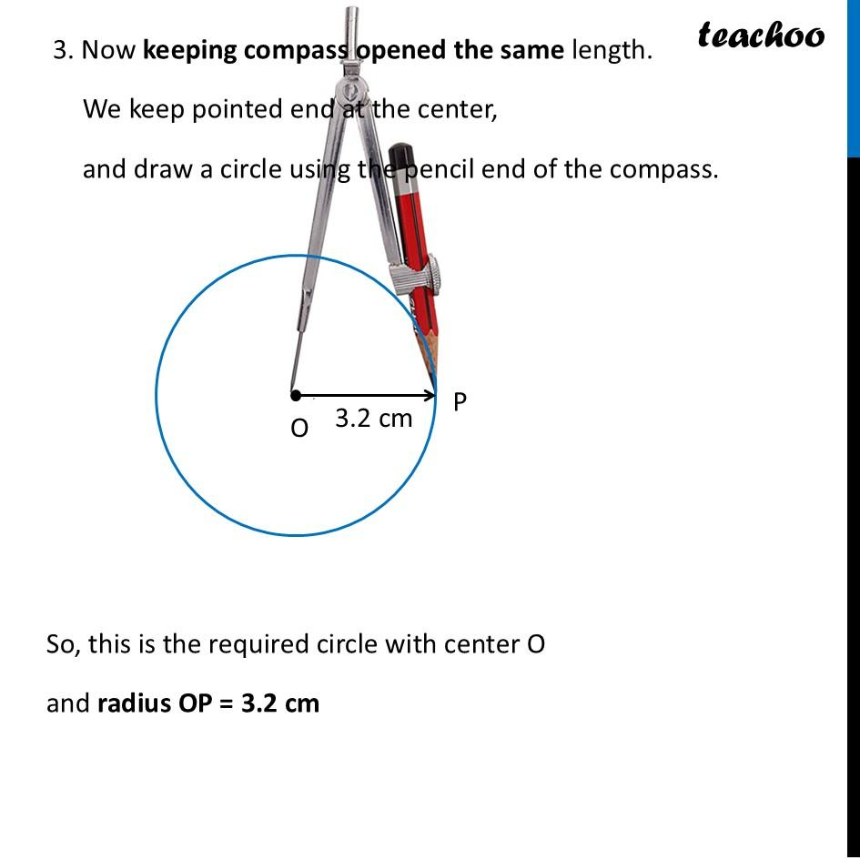
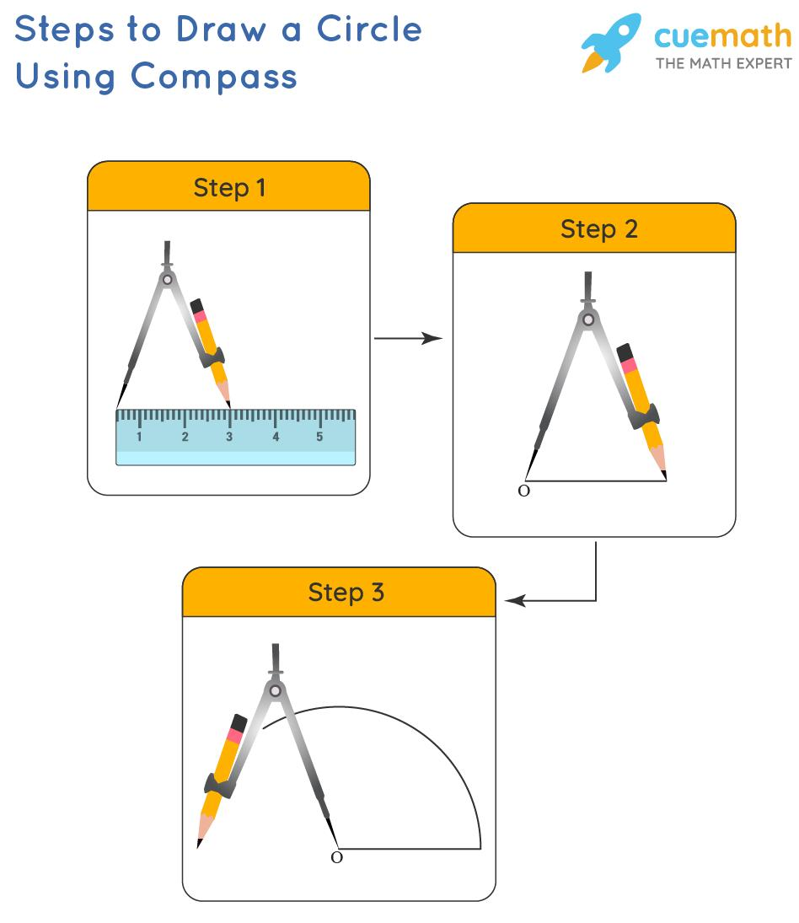
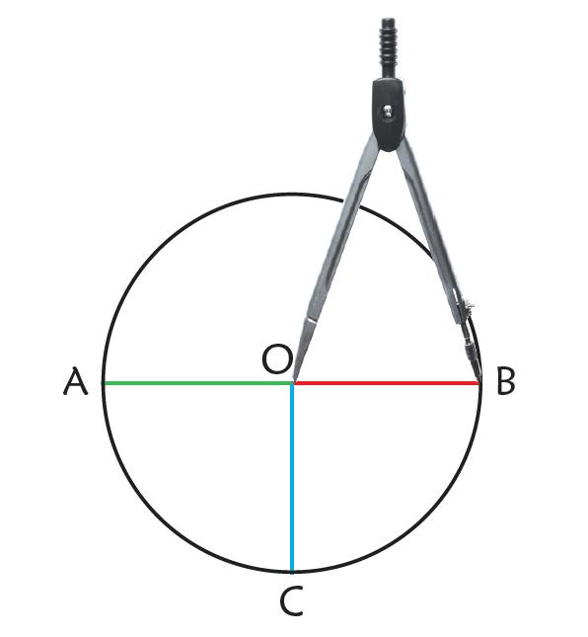
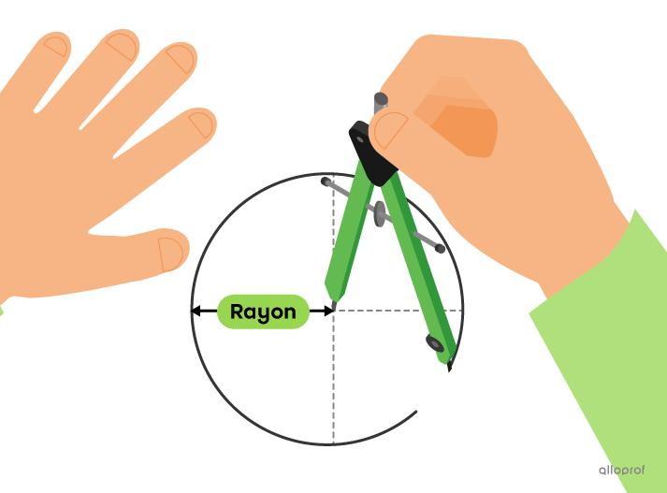

Equality from Regular-Polygon Construction
# Source: AI Source: Provided by: [Data Path: Persons Table -> ID Column: 1, Name_En Column: Motasem Essam] -> From: [ChatGPT] on [7/25/2026]
A regular polygon is constructed so that its sides and angles are equal.
For a regular hexagon:
$$\boxed{AB=BC=CD=DE=EF=FA}$$
and:
$$\boxed{∠A=∠B=∠C=∠D=∠E=∠F}$$
Regular Hexagon
A particularly useful construction uses a compass opening equal to the circle radius:
$$\boxed{s=R}.$$
Therefore all six sides have length $R$.
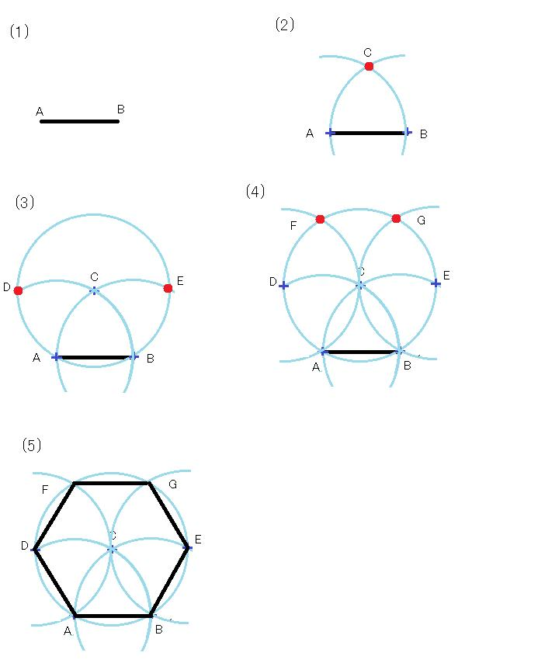
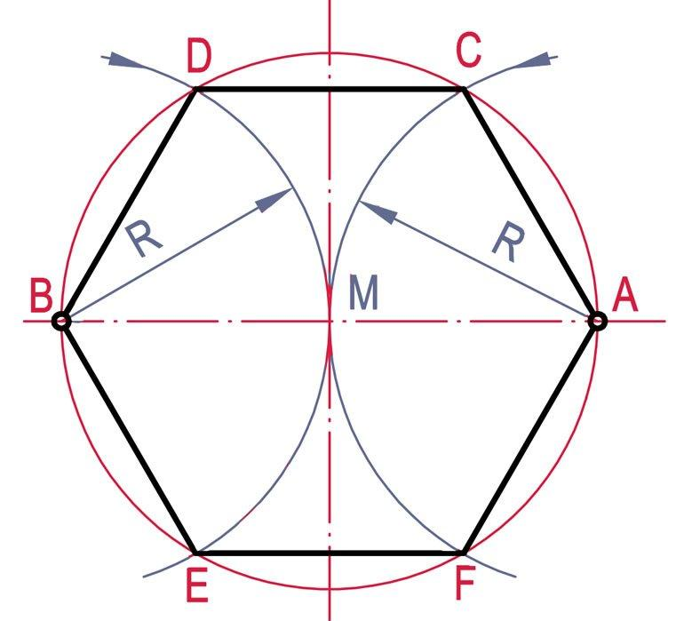
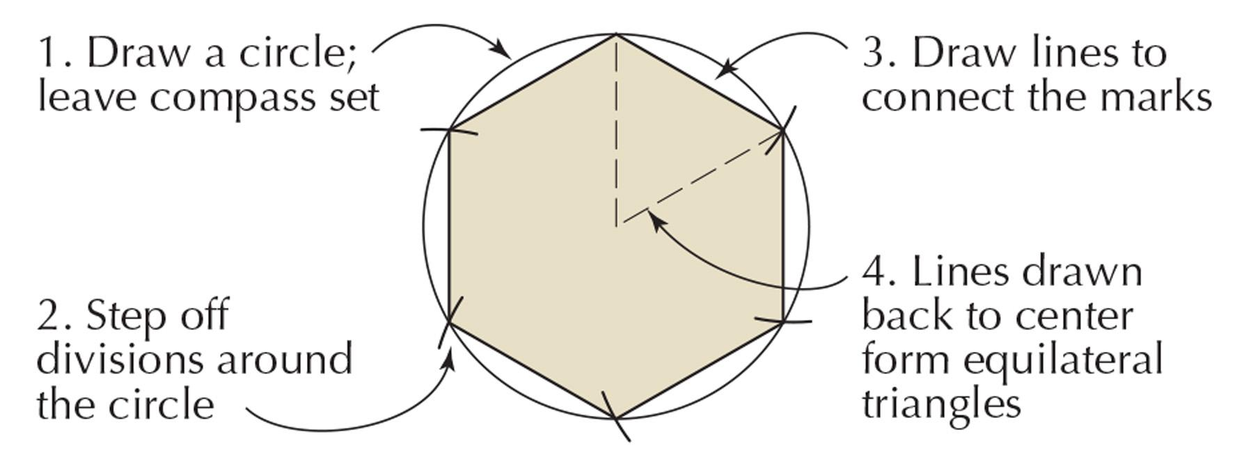
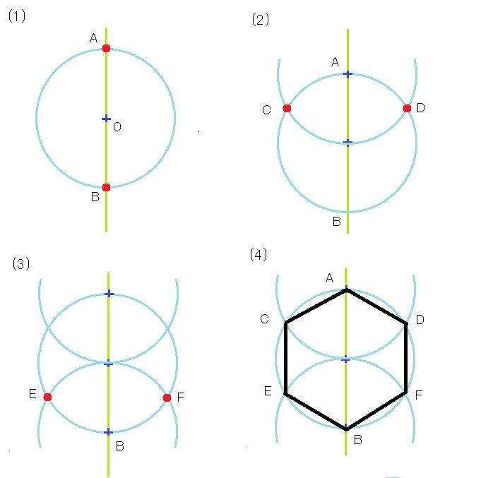
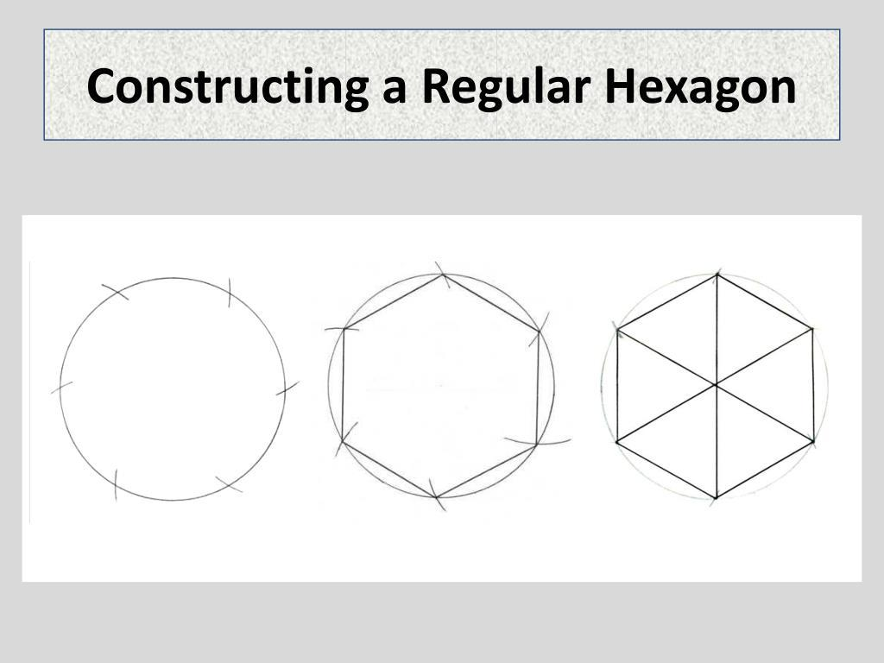
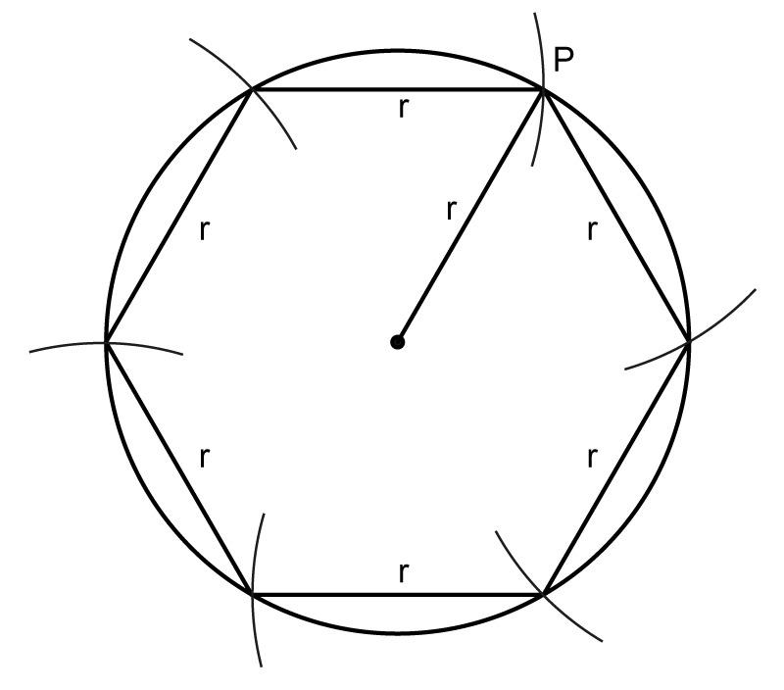

Equality from Constructed Symmetry
# Source: AI Source: Provided by: [Data Path: Persons Table -> ID Column: 1, Name_En Column: Motasem Essam] -> From: [ChatGPT] on [7/25/2026]
Construction can deliberately create symmetry.
For example, constructing the perpendicular bisector of $AB$creates reflection symmetry between $A$and $B$.
For any point $P$on the bisector:
$$\boxed{PA=PB}.$$
Similarly, constructing a regular polygon creates rotational and reflection symmetries.
For a regular hexagon:
$$\boxed{AB=BC=CD=DE=EF=FA}.$$

Equality from Circumcenter Construction
# Source: AI Source: Provided by: [Data Path: Persons Table -> ID Column: 1, Name_En Column: Motasem Essam] -> From: [ChatGPT] on [7/25/2026]
Construct the perpendicular bisectors of the sides of a triangle.
They intersect at the circumcenter $O$.
Because $O$lies on the perpendicular bisectors:
$$OA=OB$$
and:
$$OB=OC.$$
Therefore:
$$\boxed{OA=OB=OC}.$$
Thus the circumcenter is equidistant from all three vertices.
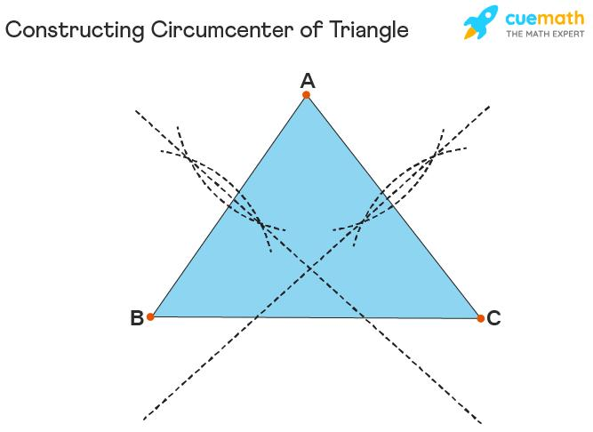
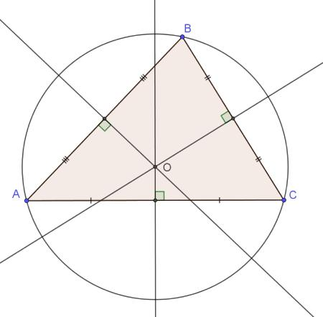
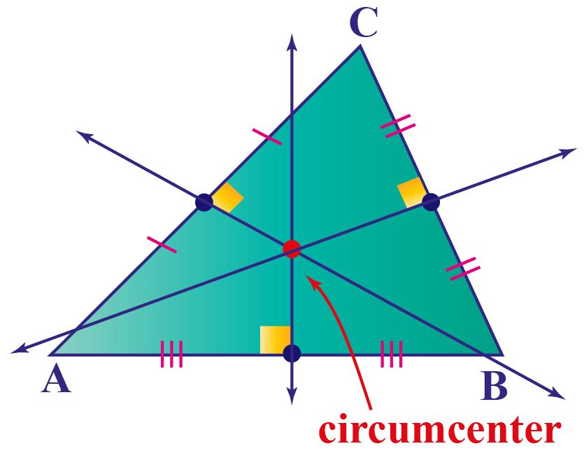
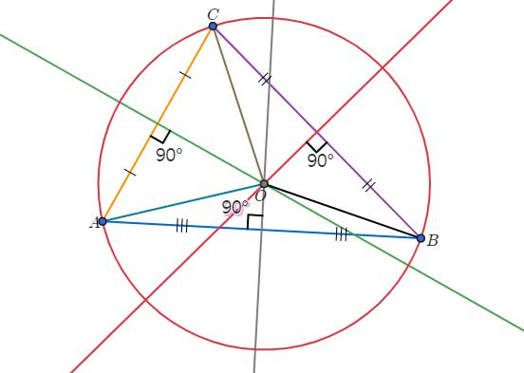
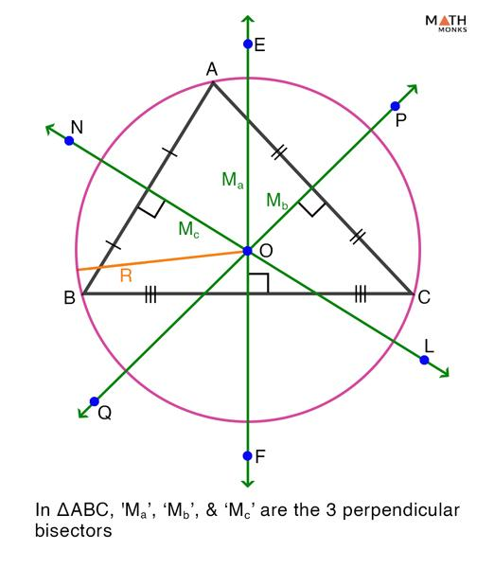

Equality from Incenter Construction
# Source: AI Source: Provided by: [Data Path: Persons Table -> ID Column: 1, Name_En Column: Motasem Essam] -> From: [ChatGPT] on [7/25/2026]
Construct the three angle bisectors of a triangle.
They intersect at the incenter $I$.
The angle-bisector construction gives:
$$\boxed{∠BAI=∠IAC} \\ \boxed{∠ABI=∠IBC} \\ \boxed{∠ACI=∠ICB}$$
The incenter also has equal perpendicular distances to the three sides:
$$\boxed{d\left(I , AB\right)=d\left(I , BC\right)=d\left(I , CA\right)}$$
The angle equalities arise directly from the constructed angle bisectors; the equal distances follow from the corresponding geometric theorems.
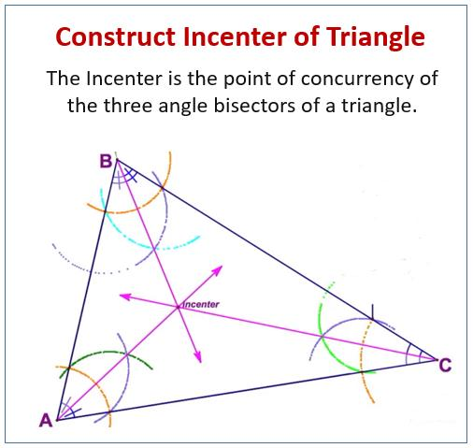
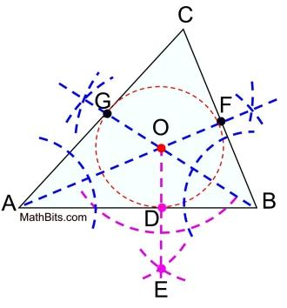
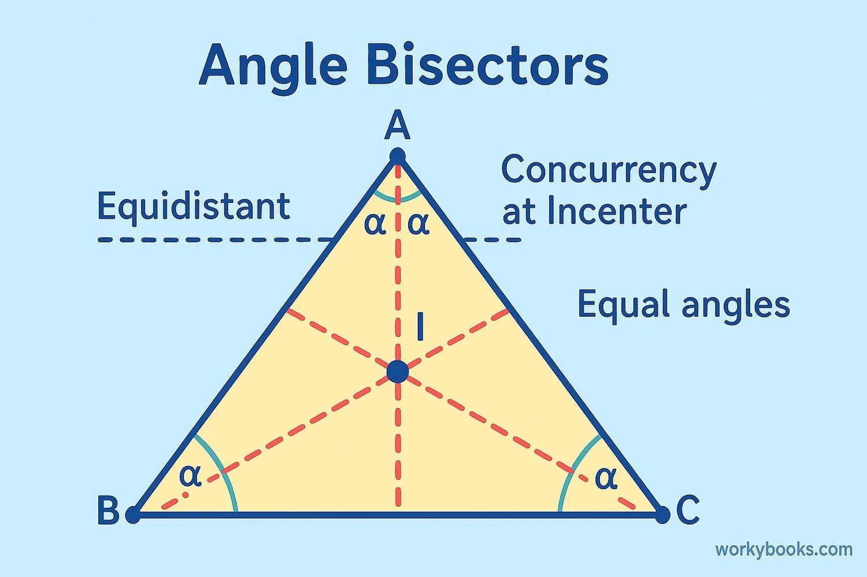
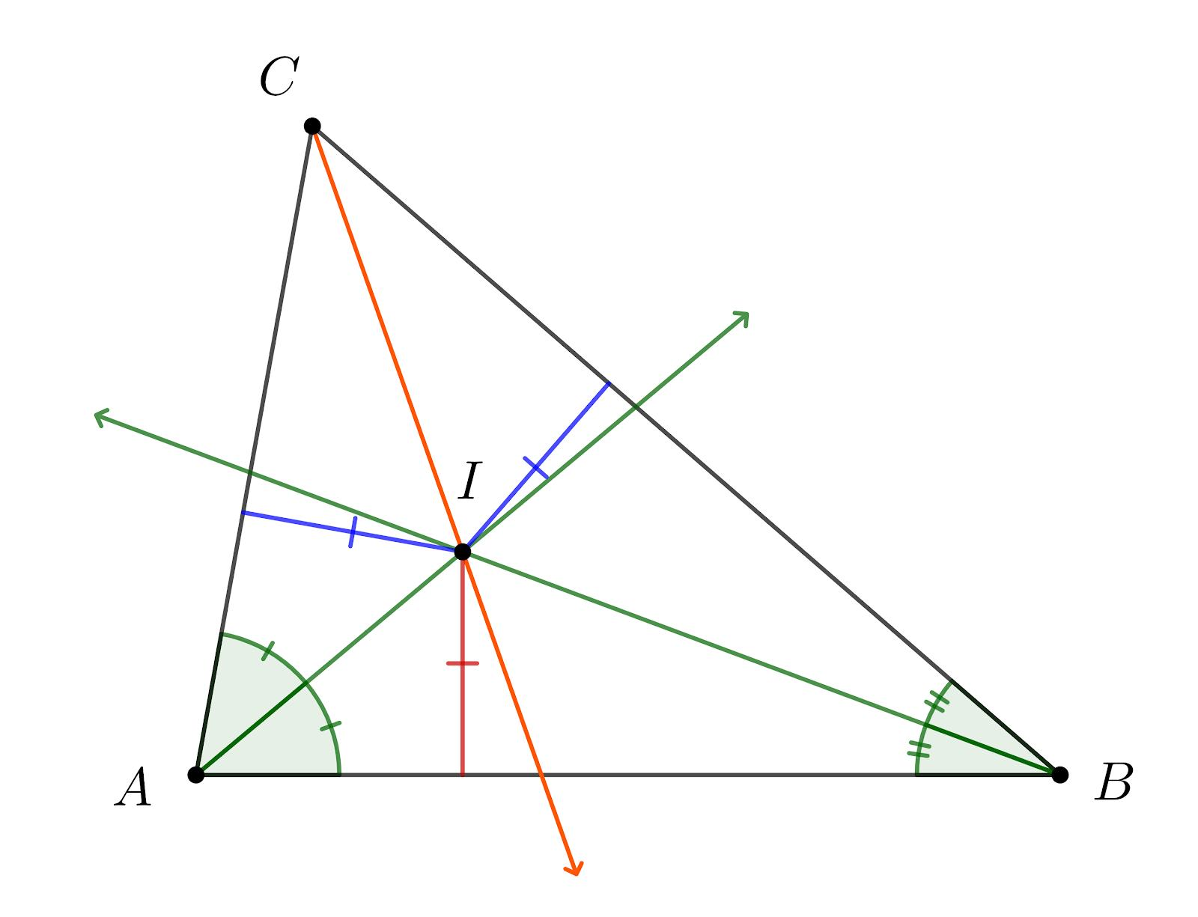
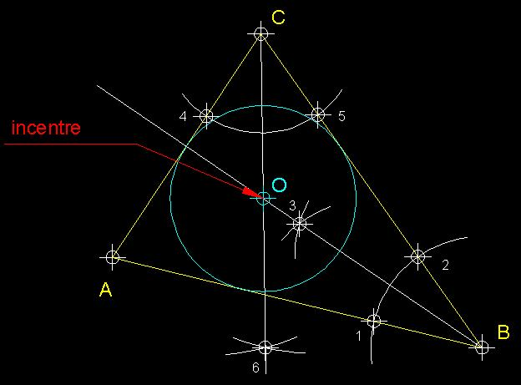
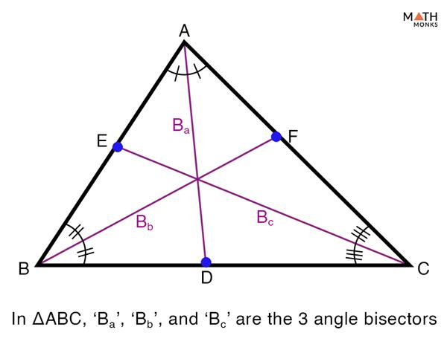

Equality from Transformation Construction
# Source: AI Source: Provided by: [Data Path: Persons Table -> ID Column: 1, Name_En Column: Motasem Essam] -> From: [ChatGPT] on [7/25/2026]
Transformations can create a new figure with equal corresponding measurements.
Translation
$$\boxed{AB=A^{'}B^{'}}$$
Rotation
$$\boxed{AB=A^{'}B^{'}}$$
Reflection
$$\boxed{AB=A^{'}B^{'}}$$
Glide Reflection
$$\boxed{AB=A^{'}B^{'}}$$
These transformations are isometries, so they preserve distances and angle measures.
Therefore:
$$\boxed{\text{Isometry}→\text{Congruent Image}→\text{Corresponding Equality}}$$
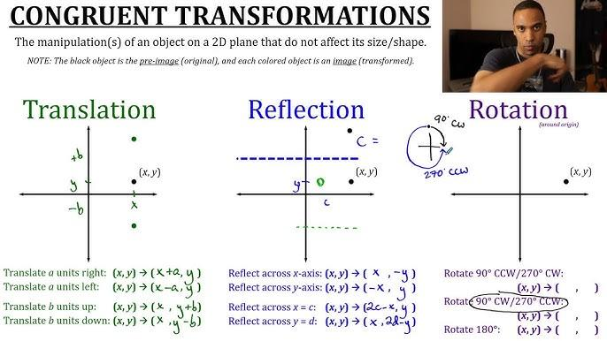
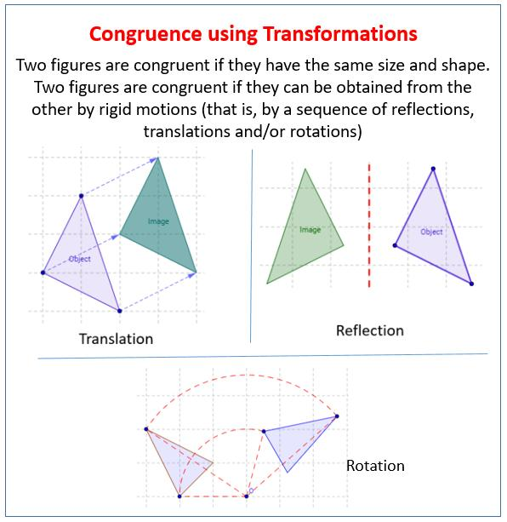
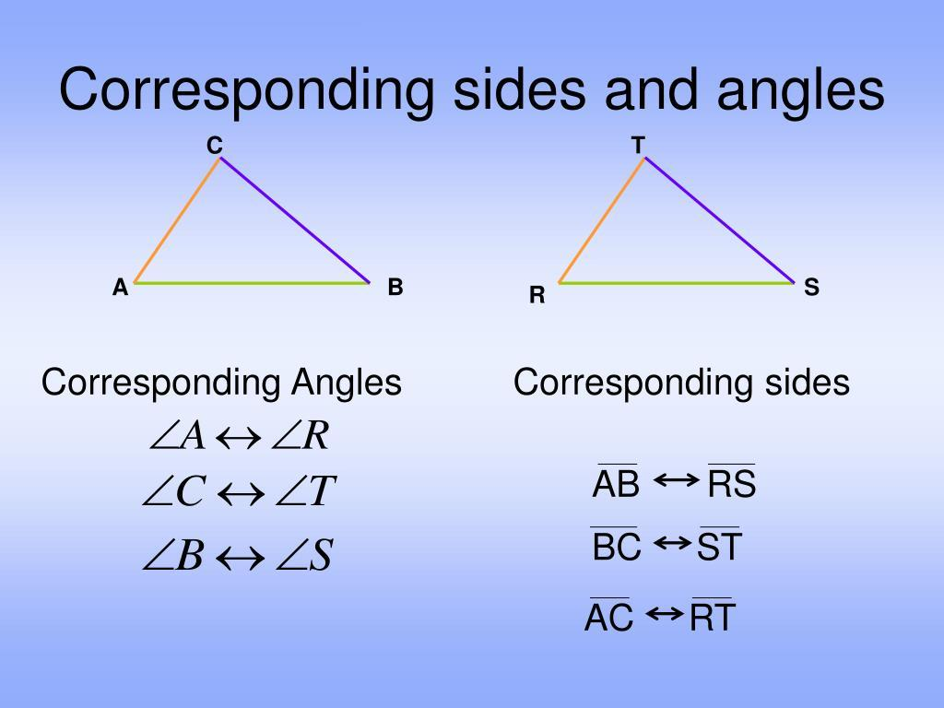
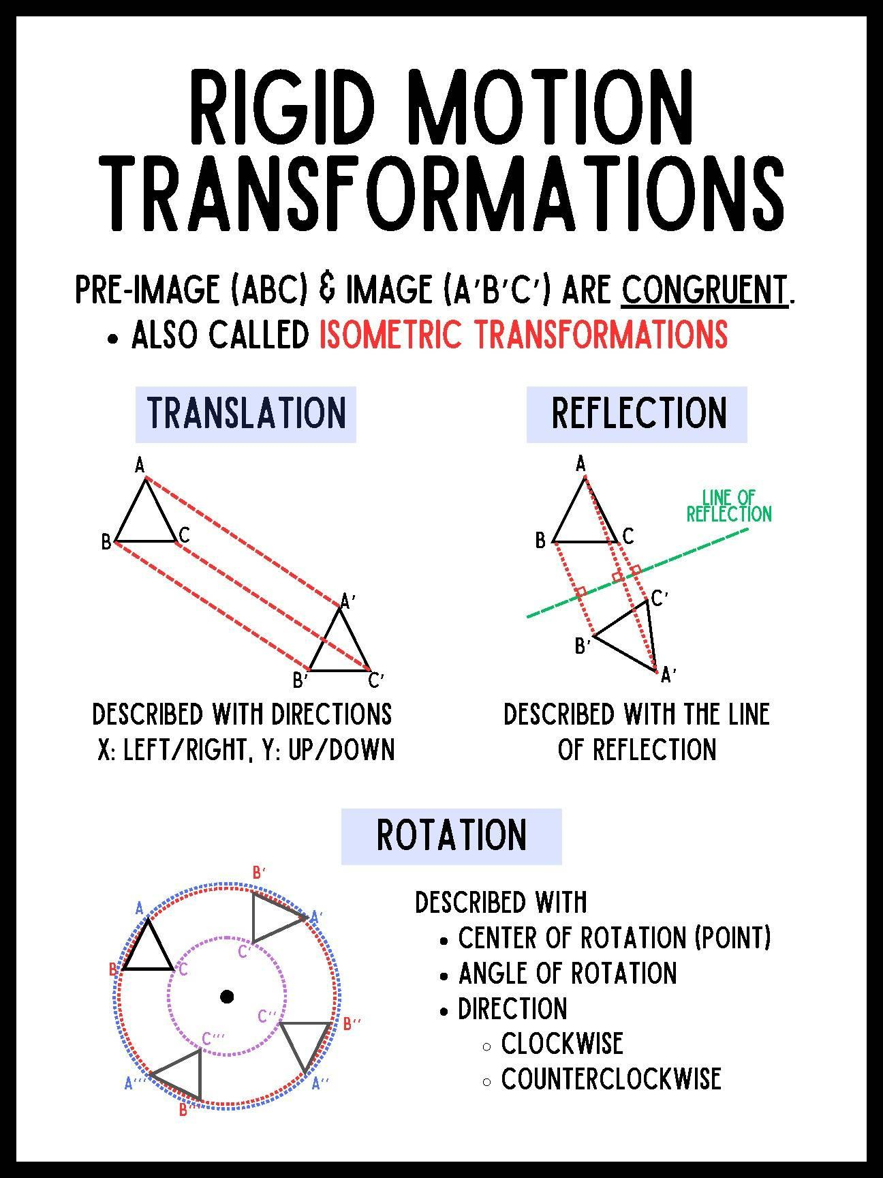
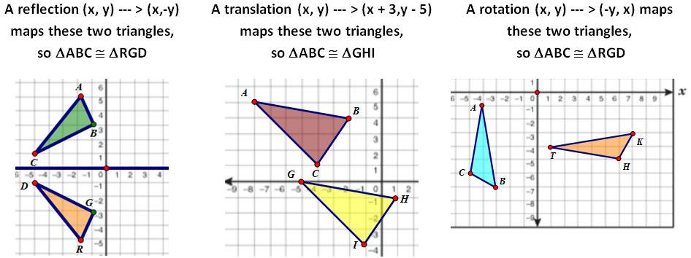

Equality from Constructed Congruent Figures
# Source: AI Source: Provided by: [Data Path: Persons Table -> ID Column: 1, Name_En Column: Motasem Essam] -> From: [ChatGPT] on [7/25/2026]
Construction can create a figure congruent to another figure.
For example, if a triangle is reconstructed using the same three side lengths:
$$AB=DE, \\ BC=EF, \\ AC=DF,$$
then:
$$\boxed{△ABC≅△DEF}.$$
Consequently:
$$\boxed{∠A=∠D} \\ \boxed{∠B=∠E} \\ \boxed{∠C=∠F}$$
and the corresponding sides are equal.
This combines:
$$\boxed{\text{Construction}→\text{Congruence}→\text{Equality}}$$

Equality in Auxiliary Constructions
# Source: AI Source: Provided by: [Data Path: Persons Table -> ID Column: 1, Name_En Column: Motasem Essam] -> From: [ChatGPT] on [7/25/2026]
A construction can also introduce an auxiliary object into a proof specifically to create an equality.
For example, suppose a proof needs a pair of equal segments. We can construct:
$$AD=BC.$$
Then the new equality may allow us to establish triangle congruence.
The general pattern is:
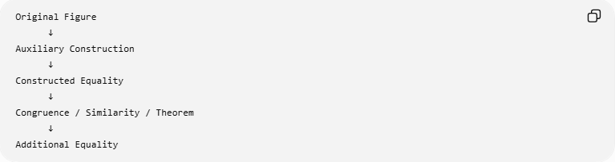
Original Figure
↓
Auxiliary Construction
↓
Constructed Equality
↓
Congruence / Similarity / Theorem
↓
Additional Equality
This is common in advanced geometry proofs.

Construction Equality vs Measurement
# Source: AI Source: Provided by: [Data Path: Persons Table -> ID Column: 1, Name_En Column: Motasem Essam] -> From: [ChatGPT] on [7/25/2026]
A construction should not be confused with measuring a drawing.
Suppose a drawing appears to show:
$$AB≈CD.$$
This does not prove:
$$AB=CD.$$
Measurement might give:
$$AB=5.01\text{ cm}$$
and:
$$CD=5.00\text{ cm}.$$
But if $CD$was constructed by copying $AB$, then the intended mathematical relationship is:
$$\boxed{AB=CD}.$$
Therefore:
$$\boxed{≈≠=}.$$

Construction Equality vs Visual Appearance
# Source: AI Source: Provided by: [Data Path: Persons Table -> ID Column: 1, Name_En Column: Motasem Essam] -> From: [ChatGPT] on [7/25/2026]
A geometric diagram may look symmetric or equal without actually being constructed that way.
For example:
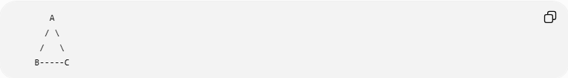
A
/ \
/ \
B-----C
The picture might appear to have:
$$AB=AC.$$
But appearance alone does not establish the equality.
A valid equality must come from:
- construction,
- definition,
- theorem,
- given information,
- calculation,
- congruence,
- similarity,
- or another valid mathematical argument.
Therefore:
$$\boxed{\text{Visual Appearance}≠\text{Mathematical Proof}}$$

Direct and Indirect Construction Equality
# Source: AI Source: Provided by: [Data Path: Persons Table -> ID Column: 1, Name_En Column: Motasem Essam] -> From: [ChatGPT] on [7/25/2026]
There are two useful ways construction can lead to equality.
Direct construction equality
The construction itself transfers or creates the equality.
Example:
$$\boxed{\text{Copy segment }AB⇒CD=AB}$$
Indirect construction equality
The construction creates conditions that allow a theorem to establish equality.
Example:
$$\boxed{\text{Construct perpendicular bisector}→\text{Perpendicular Bisector Theorem}→PA=PB}$$
Another example:
$$\boxed{\text{Construct parallel line}→\text{Parallel-Line Theorem}→∠1=∠2}$$

Construction Equality and Congruence
# Source: AI Source: Provided by: [Data Path: Persons Table -> ID Column: 1, Name_En Column: Motasem Essam] -> From: [ChatGPT] on [7/25/2026]
Construction frequently creates congruent objects.
For example:
$$\boxed{\text{Copy corresponding sides}→SSS→△ABC≅△DEF}$$
Then:
$$\boxed{\text{CPCTC}→\text{Corresponding Equality}}$$
Thus construction and congruence are closely related, but they are not the same concept.

Construction Equality and Loci
# Source: AI Source: Provided by: [Data Path: Persons Table -> ID Column: 1, Name_En Column: Motasem Essam] -> From: [ChatGPT] on [7/25/2026]
Some constructions actually construct a locus of points satisfying an equality.
Perpendicular Bisector
The locus:
$$\boxed{PA=PB}$$
is the perpendicular bisector of $AB$.
Angle Bisectors
The locus of points equidistant from two intersecting lines satisfies:
$$\boxed{d\left(P , l_{1}\right)=d\left(P , l_{2}\right)}.$$
Thus construction can be used to construct the geometric set described by an equality condition.

Major Construction-Based Equalities
# Source: AI Source: Provided by: [Data Path: Persons Table -> ID Column: 1, Name_En Column: Motasem Essam] -> From: [ChatGPT] on [7/25/2026]
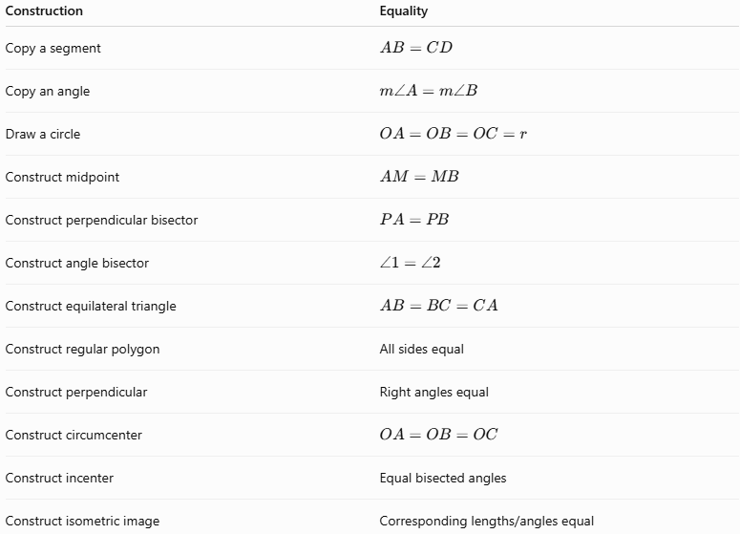
Construction | Equality
Copy a segment | $$AB=CD$$
Copy an angle | $$m∠A=m∠B$$
Draw a circle | $$OA=OB=OC=r$$
Construct midpoint | $$AM=MB$$
Construct perpendicular bisector | $$PA=PB$$
Construct angle bisector | $$∠1=∠2$$
Construct equilateral triangle | $$AB=BC=CA$$
Construct regular polygon | All sides equal
Construct perpendicular | Right angles equal
Construct circumcenter | $$OA=OB=OC$$
Construct incenter | Equal bisected angles
Construct isometric image | Corresponding lengths/angles equal

Classification Summary
# Source: AI Source: Provided by: [Data Path: Persons Table -> ID Column: 1, Name_En Column: Motasem Essam] -> From: [ChatGPT] on [7/25/2026]
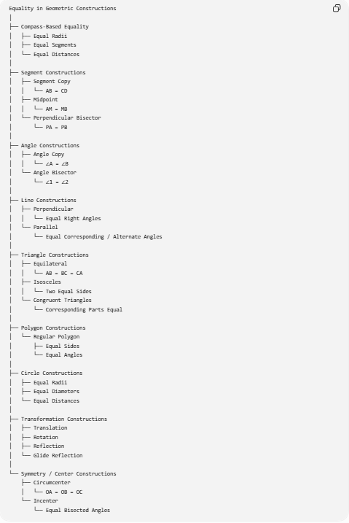
Equality in Geometric Constructions
│
├── Compass-Based Equality
│ ├── Equal Radii
│ ├── Equal Segments
│ └── Equal Distances
│
├── Segment Constructions
│ ├── Segment Copy
│ │ └── AB = CD
│ ├── Midpoint
│ │ └── AM = MB
│ └── Perpendicular Bisector
│ └── PA = PB
│
├── Angle Constructions
│ ├── Angle Copy
│ │ └── ∠A = ∠B
│ └── Angle Bisector
│ └── ∠1 = ∠2
│
├── Line Constructions
│ ├── Perpendicular
│ │ └── Equal Right Angles
│ └── Parallel
│ └── Equal Corresponding / Alternate Angles
│
├── Triangle Constructions
│ ├── Equilateral
│ │ └── AB = BC = CA
│ ├── Isosceles
│ │ └── Two Equal Sides
│ └── Congruent Triangles
│ └── Corresponding Parts Equal
│
├── Polygon Constructions
│ └── Regular Polygon
│ ├── Equal Sides
│ └── Equal Angles
│
├── Circle Constructions
│ ├── Equal Radii
│ ├── Equal Diameters
│ └── Equal Distances
│
├── Transformation Constructions
│ ├── Translation
│ ├── Rotation
│ ├── Reflection
│ └── Glide Reflection
│
└── Symmetry / Center Constructions
├── Circumcenter
│ └── OA = OB = OC
└── Incenter
└── Equal Bisected Angles

Relationship to Other Types of Geometric Equality
# Source: AI Source: Provided by: [Data Path: Persons Table -> ID Column: 1, Name_En Column: Motasem Essam] -> From: [ChatGPT] on [7/25/2026]
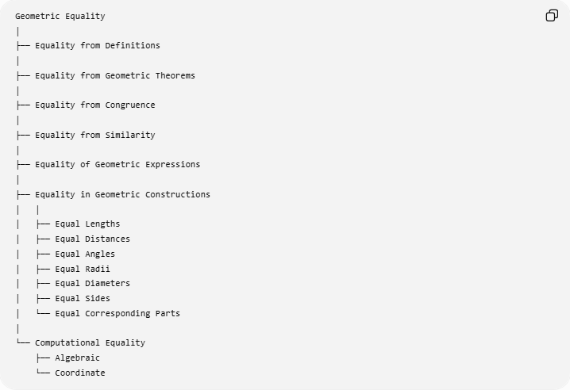
Geometric Equality
│
├── Equality from Definitions
│
├── Equality from Geometric Theorems
│
├── Equality from Congruence
│
├── Equality from Similarity
│
├── Equality of Geometric Expressions
│
├── Equality in Geometric Constructions
│ │
│ ├── Equal Lengths
│ ├── Equal Distances
│ ├── Equal Angles
│ ├── Equal Radii
│ ├── Equal Diameters
│ ├── Equal Sides
│ └── Equal Corresponding Parts
│
└── Computational Equality
├── Algebraic
└── Coordinate
The important relationship is:
$$\boxed{\text{Construction}→\text{Geometric Configuration}→\text{Equality}}$$
Sometimes a theorem is required in the middle:
$$\boxed{\text{Construction}→\text{Configuration}→\text{Theorem}→\text{Equality}}$$

Key Points
# Source: AI Source: Provided by: [Data Path: Persons Table -> ID Column: 1, Name_En Column: Motasem Essam] -> From: [ChatGPT] on [7/25/2026]
- Equality in Geometric Constructions concerns exact equalities established through construction procedures.
- A compass can transfer an exact length:
$$\boxed{AB=CD}.$$
- A midpoint construction produces:
$$\boxed{AM=MB}.$$
- A perpendicular-bisector construction produces the equal-distance relationship:
$$\boxed{PA=PB}.$$
- An angle-bisector construction produces:
$$\boxed{∠1=∠2}.$$
- An equilateral-triangle construction produces:
$$\boxed{AB=BC=CA}.$$
- A circle construction produces:
$$\boxed{OA=OB=OC=r}.$$
- Regular-polygon constructions produce equal sides and equal angles.
- Isometric transformations preserve corresponding lengths and angles.
- Construction can establish equality directly or create conditions for a theorem to establish equality.
- Measurement and visual appearance do not replace exact construction reasoning.

Conclusion
# Source: AI Source: Provided by: [Data Path: Persons Table -> ID Column: 1, Name_En Column: Motasem Essam] -> From: [ChatGPT] on [7/25/2026]
$$\boxed{\text{Equality in Geometric Constructions}=\text{Exact geometric equality created, transferred, or established through construction}}$$
The fundamental examples are:
$$\boxed{\text{Copy Segment}⇒AB=CD} \\ \boxed{\text{Midpoint Construction}⇒AM=MB} \\ \boxed{\text{Perpendicular Bisector}⇒PA=PB} \\ \boxed{\text{Angle Bisector}⇒∠1=∠2} \\ \boxed{\text{Equilateral Construction}⇒AB=BC=CA} \\ \boxed{\text{Circle Construction}⇒OA=OB=OC=⋯=r}$$
Therefore, geometric construction is not simply a way of drawing figures. It is a precise method for creating and establishing exact geometric relationships, many of which take the form of geometric equality.

